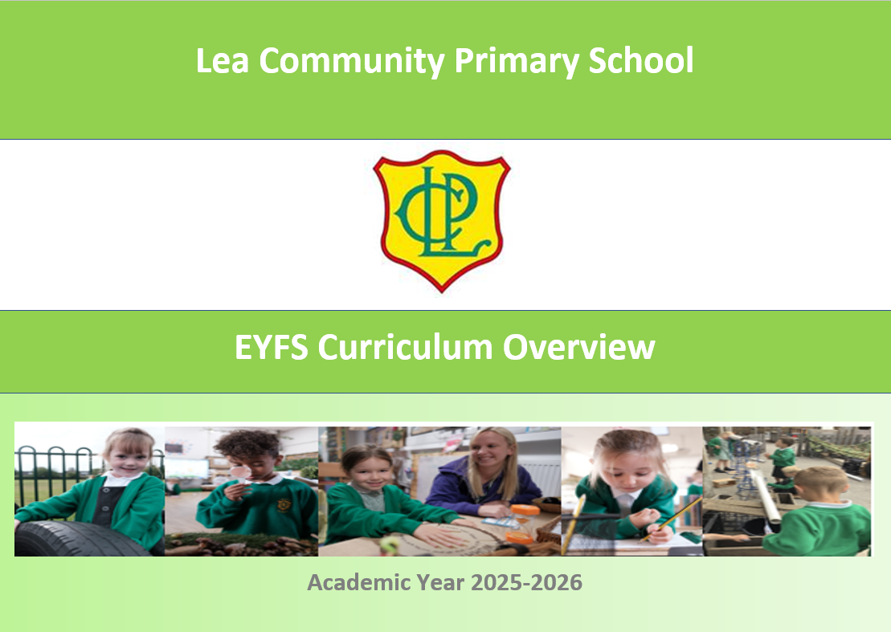

Lea Community Primary School Curriculum Overview 2026-2027

 | Autumn 1  7 weeks | Autumn 2  8 weeks | Spring 1  6 weeks | Spring 2  6 weeks | Summer 1  4 weeks 3 days | Summer 2  7 weeks
Overarching Topic | What is my story?  (All About Me) | What makes us shine?  (celebrations/ Space) | What incredible creatures have roamed our world?  (Animals/ dinosaurs) | What happened once upon a time in a land far away?  (Fairytales) | How does your garden grow?  (Plants and lifecycles) | What lies beneath the waves?  (Under the Sea)
Possible ideas/ lines of enquiry  (These may be adapted at various points to allow for children’s interests) | Birthdays  Superheroes  Autumn  Growing up  Family  Community | Space  Halloween  Bonfire Night  Diwali  Remembrance Day  Christmas  Winter | Chinese New Year  Weather  Landmarks  Recycling  Valentines Day | Spring  Easter  Looking after our world  Pancake Day  Easter  Fairy tales | Planting  Minibeasts  Exploring food | Summer  Beach  Changes- moving on  Holiday
Enrichment | Art gallery for parents  Visitors into class:  -Fire brigade  -Police  -Nurse | Walk to the post office | Little critters visit | Walk to the library | Dobbies visitor/ trip  Chicks | Zoo trip/ Sea Life Centre  Church visit
Ambitions | Police  Nurse | Astronomer | Vet  Zookeeper | Librarian | Gardener | Marine biologist
Parental  Involvement | Class Dojo updates  EYFS learning evening.  Art gallery for parents | Class Dojo updates Nativity  Parents Evening  Secret reader (parents) | Class Dojo updates  Stay and play session. | Class Dojo updates  Parent’s Picnic  Secret reader (parents) | Class Dojo updates  Writing workshop  Share a story  Stay and Read morning | Class Dojo updates  Open evening- look how far we’ve come!
CL/ Literacy  (English) | The Something  by Rebecca Cobb  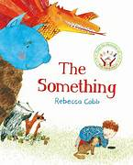 | Star in the Jar  by Sam Hay  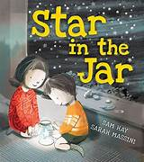 | How to Hide a Lion  by Helen Stephens  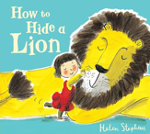  Ruby’s Worry  by Tom Percival  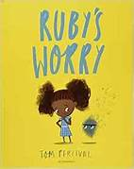 | Little Red  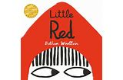  by Bethan Woollvin | Stuck  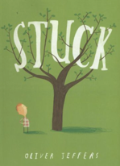  by Oliver Jeffers  There’s a Tiger on the Train  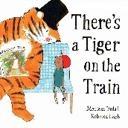  by Mariesa Dulak | The Storm Whale  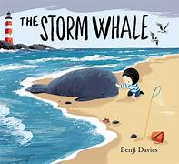  by Benji Davies
Physical Development  (PE) | PE passport: (Baseline)  Fundamental movement skills | PE passport:  How to Catch a Star | PE passport:  Rumble in the Jungle | PE passport:  Nursery Rhymes (Dance) | PE passport:  Jack and the Beanstalk  Sports Day Preparation | PE passport:  Seaside
  PSED  (PSHE) | Focus:  Settling in, routines, friendships, recognising emotions  One decision  Sessions based on the needs of the children. | Focus:  Respect, sharing, confidence, celebrating differences  One decision  Sessions based on the needs of the children. | Focus:  Teamwork, resilience, caring for others and living things  One decision  Sessions based on the needs of the children. | Focus:  Kindness, empathy, problem solving, cooperation  One decision  Sessions based on the needs of the children. | Focus:  Responsibility, independence, perseverance  One decision  Sessions based on the needs of the children. | Focus:  Collaboration, reflection, transition, independence  One decision  Sessions based on the needs of the children.
  Maths   | Subitising within 3  Counting skills  Composition of 3 and 4  Subitise objects and sounds  Comparing sets ‘just by looking’  More than/ Fewer than  Prepositional language and gestures  Cross Curricular Link: Making apple crumble (weight) | Fiveness of 5  Comparing sets ‘by matching’  Whole and part  Composition of 3,4,5  Counting skills  Matching numerals and quantities within 10  Counting beyond 20  Matching, turning, flipping  Cross Curricular Link:  Make a rocket and measure far they fly. (length) | Subitise within 5  Match numerals to quantities within 5  Ordinality  More than  Focus on 5  Recognising 6 and 7 as 5 and a bit  Comparing sets  Making equal sets  3D constructions  Difference/ equivalence  Cross Curricular Link:  Making junk modelled animals. (2D AND 3D shapes) | Ordering numbers to 8  Less than  Doubles  Odd and even numbers  Compose pictures with shapes  Sort/ classify 2D shapes  Cross Curricular Link: Design a patterned coat for Little Red (patterns) | Counting larger sets  Subitising to 6  Composition of 5 and a bit  Composition of 10  Comparision of numbers  Track games  Patterns- copying, creating, continuing  Cross Curricular Link:  Measuring the beanstalks (height) | Subitise to 5  Rekenrek  Number bonds to 5  Composition of numbers to 10  Comparison  Number patterns  Counting  Make connections in meaningful contexts  Cross Curricular Link:  Design and build a boat (capacity)
Understanding the World  (Science) | Humans & Health  My body (body parts)  Five senses  Healthy eating  Hygiene and keeping healthy | Earth & Space / Seasonal Changes  Autumn to Winter  Weather  Day and night  Sun, Moon and stars  Light and dark  Freezing water | Animals & Living Things  Animal groups and features  Habitats  Animal needs  Adult animals and their young  Simple life cycles | Materials & Forces  Naming and sorting materials  Material properties  Waterproof materials  Building and testing  Pushing, pulling, rolling, floating and sinking | Plants & Seasonal Changes  Parts of a plant  Planting and caring for plants  Plant growth  Plant life cycle  Life cycle of a chicken  Spring to Summer changes | Living Things & Habitats  Sea animals and habitats  Comparing habitats  Floating and sinking (revisit)  Water as a material  Caring for oceans and the environment
Understanding the World  (History) | Personal History  My life from baby to now  Past and present  Family memories and photographs  Changes over time | Space Exploration  Neil Armstrong and the Moon Landing  Tim Peake and modern space exploration  Significant events and people  Past and present exploration | Significant Individuals & Prehistoric Life  Mary Anning  Dinosaurs and fossils  Extinct animals  Evidence from the past | Castles, Kings & Queens  Castles  Kings and queens (past and present)  Queen Elizabeth II  Simple chronology through stories | Stories from the Past  Traditional tales  Sequencing events  Different versions of stories  Different viewpoints | Exploration & Transport  Transport past and present  Sea exploration  Journeys and travel  How travel has changed over time
Understanding the World  (Geography) | School  School environment and outdoor areas  Journey to school  Seasonal walk (Autumn): observe weather and environment using senses (see, hear, smell, feel)  Positional language (in, on, under, next to) | Weather & Hot/Cold Places  Seasonal walk (Winter)  Weather changes (rain, wind, frost, snow)  Exploring hot and cold environments  Comparing different places in the world | Local Area  Local walk (post office/ surrounding area)  Human features in the local environment (roads, buildings, shops)  Simple maps / messy maps of familiar routes  Seasonal walk (Spring) | Mapping & Journeys  Creating journey sticks  Simple maps linked to stories and journeys  Directional language (forward, backward, left, right)  Using Bee-Bots to follow simple routes | Exploration & Environments  Comparing local environment to contrasting environments  Hot and cold places / animals and environments  Developing awareness of different places in the world  Seasonal walk (Summer) | Mapping & Spatial Awareness  Creating and using simple maps  Revisiting directional language  Bee-Bots (programming simple routes)  Exploring journeys and movement in the environment
  Computing/online safety | Computing through continuous provision | Computer systems and networks  Using a computer  Online Safety | Programming 1  All about instructions | Computer systems and networks  Exploring hardware  Online safety | Programming 2  Programming Bee-Bots | Data Handling  Introduction to data  Online Safety
Understanding the World  (RE) | Special times  Key Question/s: What times are special to different people and why?  Which times are special? How and why do people celebrate? What would I like to celebrate and why? |  | Special stories  Key Question/s: Which stories are special to different people and why?  What makes something special? Where can people find sacred stories? What is my favourite story and why? |  | Special places  Key Question/s: Which places are special to different people and why?  Do we behave differently in different places? Which places are thought to be sacred? Which place is sacred to me?
Expressive Arts  (Art) | Drawing & mark making  Artist: Pablo Picasso  Drawing & mark making (portraiture)  Self-portraits using line and shape  Facial features  Exploring identity through drawing  Outcome: Self-portrait (Pencil drawing)  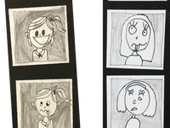 | Painting & expressive mark making  Artist: Vincent Van Gogh  Fireworks and night skies  Space-inspired scenes  Mixing dark/light tones  Swirling brush techniques  Outcome: Starry Night (Poster painting)  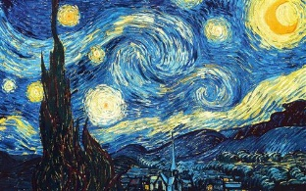 | Collage & mixed media  Artist: Megan Coyle  Layering and cutting materials  Texture, pattern and colour building  Using recycled materials creatively  Outcome: Collaborative Art (Collage animals)  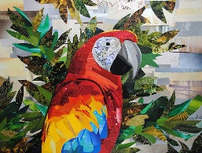 | Printmaking  Artist: William Morris  Exploring repeated patterns  Printing with foam, leaves or stamps  Colour selection  Composition  Nature-inspired design  Outcome: Printed Artwork (Fairytale Forest)  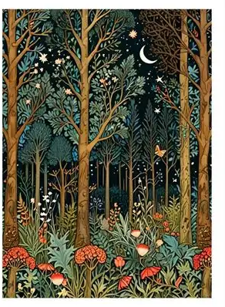 | Observation drawing & watercolour  Artist: Georgia O’Keefe  Plants, flowers, insects  Close observational drawing  Watercolour techniques and blending  Outcome: Watercolour painting (flowers)  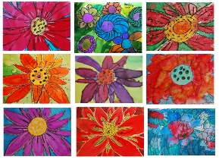 | Sculpture & 3D form  Artist: Beth Cavener  Clay modelling techniques  Texture, structure and form  Outcome: 3D Sculpture  (Clay animal sculpture)  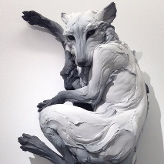
Expressive Arts  (Design and Technology) | Paper Manipulation  Exploring different ways to manipulate paper  Scrunch, fold, bend, rip, curl and cut paper  Joining paper using glue and tape  Outcome: Create a self-portrait collage | Mechanisms  Exploring simple moving mechanisms  Investigating sliders in books and cards  Designing and making a Christmas card with a slider  Testing and evaluating moving parts  Outcome: Christmas card with a slider | Junk modelling  Exploring recycled and construction materials  Selecting and joining materials for a purpose  Building stable structures using different joining techniques  Outcome: Recycled dinosaur or animal model | Structures  Exploring how structures can be strong and stable  Selecting materials for a purpose  Designing and building a fairytale house or castle  Testing and improving finished structures  Outcome: Fairytale house or castle | Cooking & Nutrition  Exploring healthy and seasonal foods  Preparing ingredients safely using simple tools  Following a simple recipe  Talking about healthy food choices  Outcome: Apple crumble | Textiles  Exploring fabrics, thread and weaving  Developing threading and weaving skills  Using simple joining techniques  Evaluating finished textile creations  Outcome: Woven or threaded sea creature
Expressive Arts  (Music) | Ourselves and our friends  Musical elements  Pitch  Tempo  Duration  Structure | Nativity songs  Musical elements  Pitch  Tempo  Dynamics | Dinosaurs  Musical elements  Pitch  Dynamics  Duration  Timbre | Bears  Musical elements  Duration  Dynamic  Tempo  Pitch  Structure  Timbre | Gardens and growing  Musical elements  Pitch  Tempo  Timbre  Dynamics  Structure | Seaside and Under the Sea  Musical elements  Pitch  Timbre  Texture

