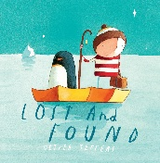
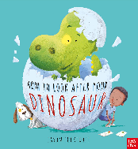
Curriculum Overview
Communication and Language/ Literacy | Physical Development | Personal, Social and Emotional Development
This term we will continue to develop our reading and writing skills through our daily phonics lessons. In Literacy, we will be continuing with Drawing Club. The children will be exploring a range of high- quality texts to extend their vocabulary and imagination.  We will also be looking at the story ‘How to Look After Your Dinosaur’ and learning how to retell the story orally as well as label pictures and write captions as our phonics skills progress. We will continue to develop our vocabulary through discussions and listening to stories. We will also learn and perform the rhyme ‘Down in the Jungle’ with actions and props. | P.E. sessions will take place on a Thursday. Children  will be expected to arrive at school wearing their  P.E kit. Please could you ensure long hair is tied  back and jewellery is removed to avoid any  accidents. This half term, we will continue to  develop their fundamental movement skills such as  hopping, jumping, running, throwing and catching.  We will be doing this using the topic ‘Rumble in the  Jungle’. In class we will be working hard to develop  our finger muscles through lots of fine motor  activities | This half term we will continue to develop our  personal, social and emotional skills. We will be  learning how to develop our resilience and  perseverance when faced with challenges.  We will be continuing our peer massage sessions to  help us to feel calm and emotionally prepared to  learn.
Mathematics | Understanding the World | Expressive Art and Design
This half term, we will be learning how to count to  20, as well as developing our maths skills by learning  how to represent quantities on our fingers. We will  start to recall number bonds to 5 and begin to  understand how to make unequal groups equal.  This term in shape, space and measure we will begin  to develop our mathematical language to describe  length, height and weight. | This half term we will be learning about animals  around the world and what animals need to survive.  We are also exploring the significant person Mary  Anning and exploring how she found fossils and  what her job is. We will also look at contrasting  environments around the world and discuss  differences. We will look at the changes in the  weather and discuss what happens in Wintertime.  In RE, we will look at stories and why they are  special | In Art, we will be completing landscape collages  with inspiration from the artist Megan Coyle.  In DT, we will explore junk modelling further,  building on our prior knowledge to use recycled  materials to make junk modelled dinosaurs and  animals. In Music, we will be exploring new  vocabulary such as pitch and dynamics
Our learning this half term will be linked to the enquiry question ‘Who Makes the Rules?’ This is our umbrella topic which means it is flexible and we always consider children’s interests to motivate them.

Homework Overview
Reading |  | Maths |  | Phonics
Please ensure you read with your child as frequently as possible. Book changing day is on Fridays. Asking your child questions in relation to the book they are reading can help to develop their comprehension skills. Reading regularly with your child is essential to their early reading. |  | Please explore these websites to support your child with their understanding of numbers to 5 and subitising.  https://www.topmarks.co.uk/Search.aspx?Subject=16&AgeGroup=1  https://ictgames.com/mobilePage/index.html |  | We will upload lots of simple phonics games to Class Dojo to help your child build their phonological knowledge at home.  You can also access some of the free games from the following websites:  www.phonicsplay.co.uk  www.phonicsbloom.com
Understanding the World Challenge | Expressive Arts Challenge |  | Personal social and emotional development Challenge |  | Physical development Challenge
Research some facts about Mary Anning and make a fact book with your grown up to share with the class.  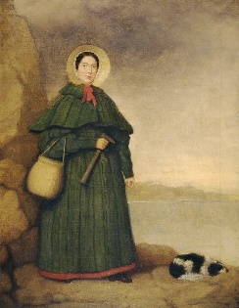 | 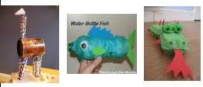  Can you make a junk model of your favourite animal? Bring it in and we can put it on our display to show all your friends! |  | In class, we are practising our sharing and turn taking skills. Can you play a board game at home with your grownups or brothers or sisters? Don’t forget to take turns!   |  | Go for a walk with your grown-ups and look out for signs of winter  Send a picture or a video in on Class Dojo!  


