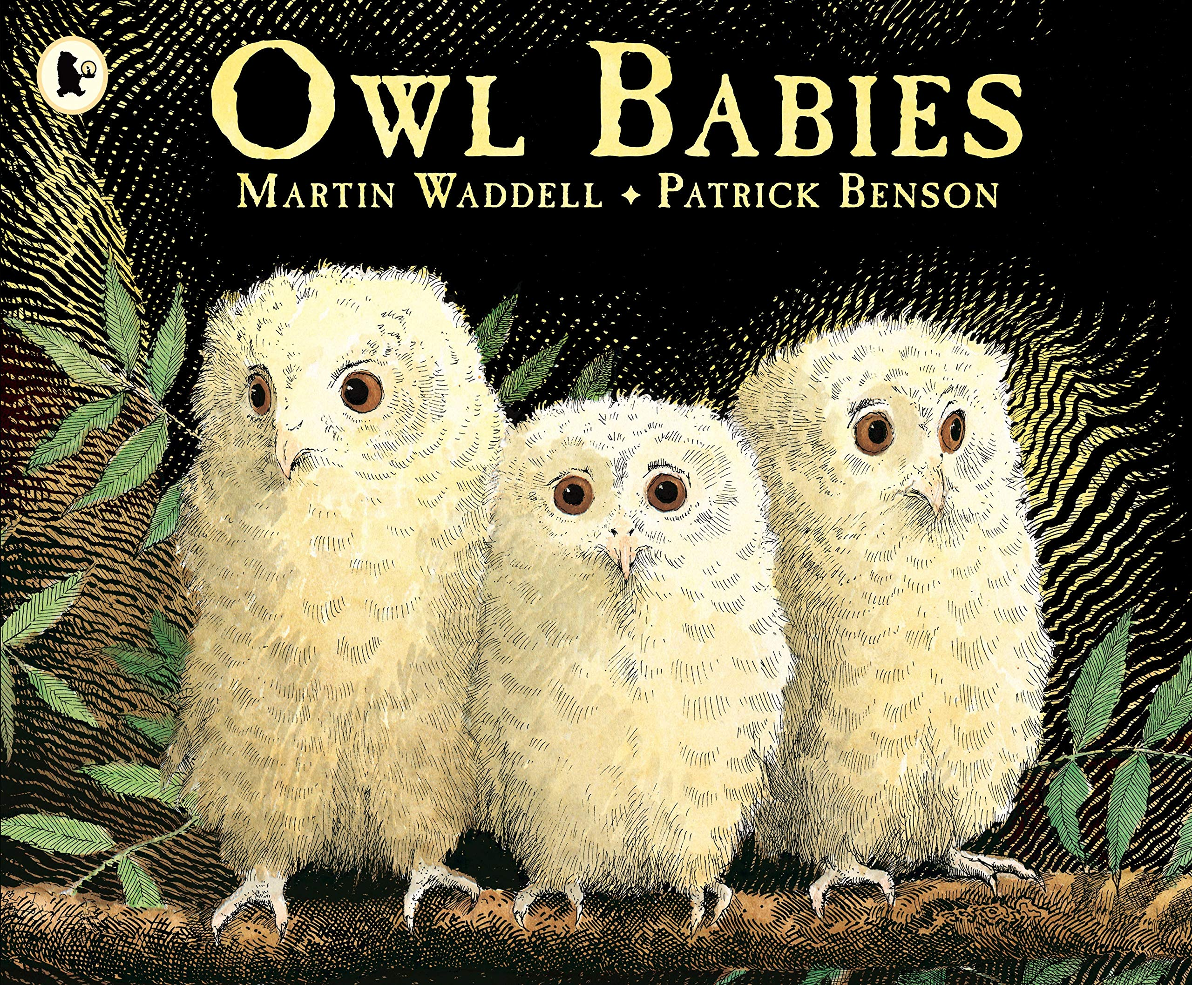
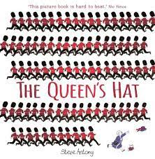
Curriculum Overview
Our learning this half term will be linked to the enquiry question ‘Who Makes the Rules?’ This is our umbrella topic which means it is flexible and we always consider children’s interests to motivate them.
Communication and Language/ Literacy | Physical Development | Personal, Social and Emotional Development
This term we will continue to develop our reading and writing skills through our daily phonics lessons. In Literacy, we will be continuing with Drawing Club. The children will be exploring a range of high- quality texts to extend their vocabulary and imagination.  We will also be looking at the story ‘The Queen’s Hat’ and learning how to retell the story orally as well as label pictures and write captions as our phonics skills progress. We will continue to develop our vocabulary through discussions and listening to stories. We will also learn and perform the rhyme ‘The Grand Old Duke of York’ with actions and props. | P.E. sessions will take place on a Thursday. Children will be expected to arrive at school wearing their P.E kit. Please could you ensure long hair is tied back and jewellery is removed to avoid any accidents. This half term, we will continue to develop their fundamental movement skills such as hopping, jumping, running, throwing and catching. We will be doing this using the theme castles. In class we will be working hard to develop our finger muscles through lots of fine motor activities. | This half term we will be focussing on ourselves and our emotions. We will be discussing turn taking and sharing and thinking about taking other children’s feelings into consideration. We will also be considering why we have rules and how they keep us safe.  This term we are continuing to support children to build constructive and respectful relationships with adults and peers.  We will be continuing our peer massage sessions to help us to feel calm and emotionally prepared to learn.
Mathematics | Understanding the World | Expressive Art and Design
This half term, we are continuing to look at the composition of number and our ability to subitise and 1:1 counting.  This term we will focus on the composition of 3,4 and 5 and that 2 parts make a whole. We will also be focussing on matching numerals within 10 and exploring 2D shapes, along with exploring repeating patterns. | This half term we will be learning about people in the community and their roles. We will explore different occupations and discuss their importance. We will also think about different celebrations such as Bonfire night, Remembrance Day, Diwali and Christmas. We will look at the changes in the weather and discuss what happens in Wintertime. In RE, we will be thinking about different celebrations and how we celebrate them. | In Art, we will be developing our painting skills by creating a selection of artwork individually and collaboratively. We will also create artwork inspired by the artist Kandinsky. In DT, we will continue to develop our imaginative skills by using a range of junk modelling equipment to create a desired outcome. We will also be following instructions to create Christmas cards with a slider mechanism.

Homework Overview

Reading |  | Maths |  | Phonics
Please ensure you read with your child as frequently as possible. Book changing day is on Fridays. Asking your child questions in relation to the book they are reading can help to develop their comprehension skills. Reading regularly with your child is essential to their early reading. |  | Please explore these websites to support your child with their understanding of numbers to 5 and subitising.  https://www.topmarks.co.uk/Search.aspx?Subject=16&AgeGroup=1  https://ictgames.com/mobilePage/index.html |  | We will upload lots of simple phonics games to Class Dojo to help your child build their phonological knowledge at home.  You can also access some of the free games from the following websites:  www.phonicsplay.co.uk  www.phonicsbloom.com
Understanding the World Challenge | Expressive Arts Challenge |  | Personal social and emotional development Challenge |  | Physical development Challenge
Have a look at the jobs in the community. Which one is your favourite and why? Would you like to do any of these jobs when you grow up? You could draw a picture of your favourite job and bring it into school to share with your friends!  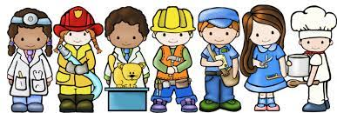 | Think about a job in the community. Can you use junk modelling to create something they use in their job? You could create a doctor’s bag, a police car, a fire engine! Have a think about the different materials you will use. How will you attach them? What colour does it need to be?  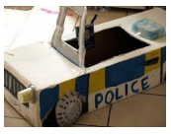 |  | In class, we are practising our sharing and turn taking skills. Can you play a board game at home with your grownups or brothers or sisters? Don’t forget to take turns!   |  | Can you create your own obstacle course?  You could include the fundamental skills of: hopping, jumping, running, throwing and catching.  Send a picture or a video in on Class Dojo so we can all see your amazing work!  

