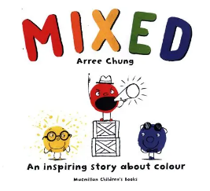
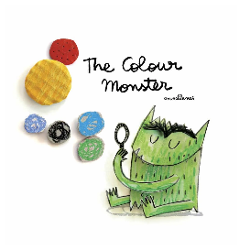
Curriculum Overview
Our learning this half term will be linked to the enquiry question ‘Who Am I?’ This is our umbrella topic which means it is flexible and we always consider children’s interests to motivate them.
Communication and Language/ Literacy | Physical Development | Personal, Social and Emotional Development
We will be looking at a range of stories linked to starting school, emotions and seasons. We will begin to extend our oracy skills and vocabulary through singing lots of nursery rhymes as well as learning ‘The Hedgehog Song’ by Lee Mottram. This term we will start to develop our reading and writing skills through our daily phonics lessons. | P.E. sessions will take place on a Thursday. Children will be expected to arrive at school wearing their P.E kit. Please could you ensure long hair is tied back and jewellery is removed to avoid any accidents. This half term, the children will be developing their fundamental movement skills such as hopping, jumping, running, throwing and catching. In class we will be working hard to develop our finger muscles through lots of fine motor activities. | This half term we will be focussing on establishing new routines and encouraging children to form positive relationships with staff and peers. Children will talk about lots of different topics during key worker time, particularly discussions around emotions and the importance of personal hygiene. We will also begin our peer massage sessions to help us to feel calm and emotionally prepared to learn.
Mathematics | Understanding the World | Expressive Art and Design
This half term, we will focus on learning lots of different number nursery rhymes such as ‘5 little ducks’ and ‘5 speckled frogs’. In our maths sessions, we will begin to develop lots of skills such as subitising, 1:1 counting and extending our knowledge of the composition of numbers to 4. We will | This half term we will be focusing on developing our chronological knowledge by comparing what we needed as a baby to what we need now. We will also look at how the local area has changed over the years. We will be focussing on the importance of good hygiene. We will look at the changes in the weather and discuss what happens in Autumn time. In RE, we will be thinking about different celebrations and how we celebrate them. | In Art, we will be developing our drawing skills by creating self-portraits. We will explore a range of mark making materials and learn how to use equipment safely and effectively. In DT, we will develop our imaginative skills by using a range of junk modelling equipment to create a desired outcome.

Homework Overview


