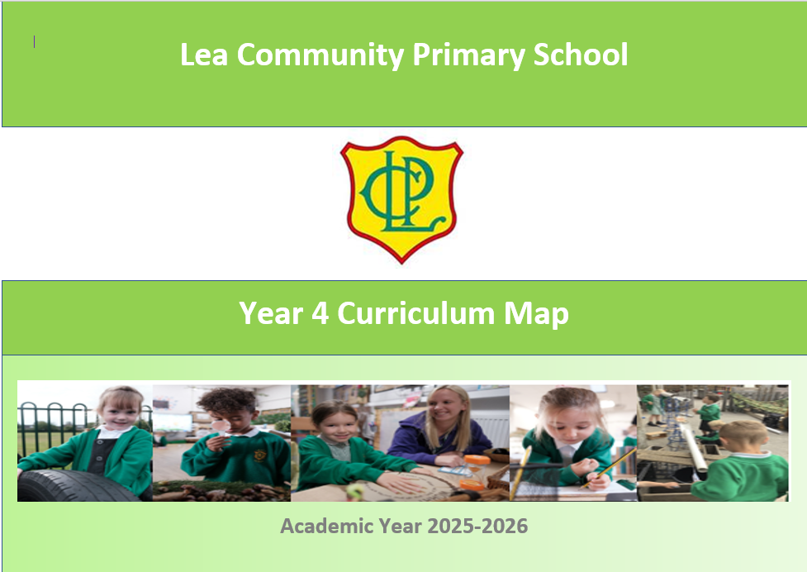

 | Autumn 1 | Autumn 2 | Spring 1 | Spring 2 | Summer 1 | Summer 2
 | 8 weeks | 7 weeks | 6 weeks | 5 weeks | 6 weeks | 6 weeks
Topic | Can you believe everything you see? | Fact or fiction? | Why are rainforests important to us? | Can you help save the world? | How did the achievements of the Ancient Maya impact their society? | How is sound made?
Enrichment |  | Hindu visitor/ visit to Hindu temple  Swimming | Fieldwork- geography trip | Egyptian visitor | Ancient Maya visitor | River day
Core Texts | The Treasure of the Loch Ness Monster  Bridging Unit by Lari Don  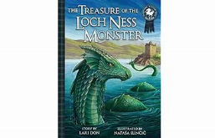 | Rumaysa by Radiya Hafiza  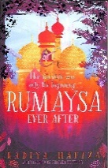  Let it Go Song by Frozen | Woof by Alan Ahlberg  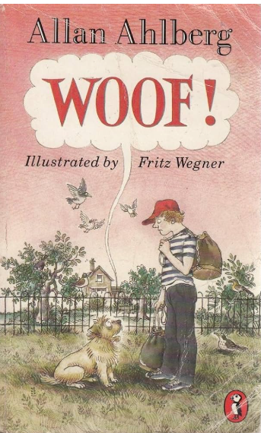  Persuasive adverts | Last Bear by Hannah Gold  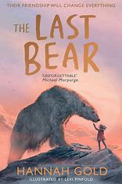  Various persuasive texts (see link texts)  Poem based on BGT Aneeshwar Kunchala audition | Gulliver's Travels by Miss Marie Crook  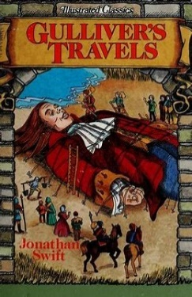 | Macavity by T.S Eliot  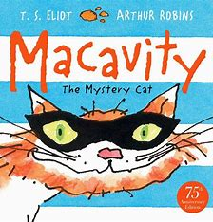
Hinterland knowledge | Fiction  Unsolved Mysteries of the Loch Ness monster  True Story of the Loch Ness Monster  The Water horse by Dick King Smith  Non Fiction  History’s mysteries: Freaky phenomena: Curious clues, cold cases and puzzles  Legend of Loch Ness Monster for kids  Behind the Legend- The Loch Ness monster  Range of websites linked to Loch Ness (See Bridging Unit) | Fiction  Matilda  Alice in Wonderland  101 Dalmatians  Aladdin  Peter Pan  An Owl called Star  Non Fiction  Range of websites linked to Owls | Fiction  Hunter’s icy adventures  The girl who went on strike to save the planet  Non Fiction  Eco Kids  What is climate change?  Fund out Climate Change  A climate in chaos  BGT- climate change audition  Young people’s trust for environment/ climate change  Frozen planet | Non Fiction  Eco Kids  What is climate change?  Fund out Climate Change  A climate in chaos  BGT- climate change audition  Young people’s trust for environment/ climate change  Frozen planet  Poetry  Haiku Poems (see sightline website on climate change Haikus)  The rang tan advert  Greenpeace advert | Fiction  Fig’s Giants  Gulliver’s Travels 1939 Film on YouTube  Gulliver’s Travels 1977 Film  Gulliver’s Travels 2010 Film  Dancing Bear  Clockwork  The Ice Palace  Non Fiction  Information texts on place chosen (linked to Geography or fictional place from novel)  Planet Earth by Katie Daynes.  Usborne First Encyclopaedia of Our World  What is a map? from the Espresso website  Artist factsheets from the Espresso website | Non Fiction  Shaun the Space Sheep  Various newspaper reports with interesting headline  Fiction  Max the detective cat  Six Dinner Sid  Evil Secret Society of Cats  Varjak Jaw  Toto the Ninja Cat  To be A Cat  Poetry  Atticus Claw breaks the Law
English | Narrative  Non-chronological reports | Narrative | Narrative  Persuasion | Narrative  Poetry | Narrative  Newspaper reports | Poetry  Newspaper reports
Maths | Place value  Addition and subtraction  Angles and shape | Rounding  Column addition and subtraction  Angles and shape  Symmetry | Multiplication  Co-ordinates | Multiplication and division  Length  Area and Perimeter | Decimals  Area and Perimeter | Fractions  Money  Time
Science | Animals: Digestion and Food  National Curriculum  Describe the simple functions of the basic parts of the digestive system in humans.  Identify the different types of teeth in humans and their simple functions.  Construct and interpret a variety of food chains, identifying producers, predators and prey. | Electricity and Circuits  National Curriculum  Identify common appliances that run on electricity.  Construct a simple series electrical circuit, identifying and naming its basic parts, including cells, wires, bulbs, switches and buzzers.  Identify whether or not a lamp will light in a simple series circuit, based on whether or not the lamp is part of a complete loop with a battery.  Recognise that a switch opens and closes a circuit and associate this with whether or not a lamp lights in a simple series circuit. Recognise some common conductors and insulators, and associate metals with being good conductors.  Ambitions link: electrician | Living things: Classification and changing habitats  National Curriculum  Recognise that living things can be grouped in a variety of ways.  Explore and use classification keys to help group, identify and name a variety of living things in their local and wider environment.  Recognise that environments can change and that this can sometimes pose dangers to living things. | Materials: States of Matter  National Curriculum  Compare and group materials together, according to whether they are solids, liquids or gases.  Observe that some materials change state when they are heated or cooled, and measure or research the temperature at which this happens in degrees Celsius (°C).  Identify the part played by evaporation and condensation in the water cycle and associate the rate of evaporation with temperature. |  | Energy: Sound and vibrations  National Curriculum  Identify how sounds are made, associating some of them with something vibrating.  Recognise that vibrations from sounds travel through a medium to the ear.  Find patterns between the pitch of a sound and features of the object that produced it.  Find patterns between the volume of a sound and the strength of the vibrations that produced it.  Recognise that sounds get fainter as the distance from the sound source increases.
Working Scientifically | National Curriculum  Asking relevant questions and using different types of scientific enquiries to answer them.  Setting up simple practical enquiries, comparative and fair tests.  Making systematic and careful observations and, where appropriate, taking accurate measurements using standard units, using a range of equipment, including thermometers and data loggers.  Gathering, recording, classifying and presenting data in a variety of ways to help in answering questions.  Recording findings using simple scientific language, drawings, labelled diagrams, keys, bar charts, and tables.  Reporting on findings from enquiries, including oral and written explanations, displays or presentations of results and conclusions.  Using results to draw simple conclusions, make predictions for new values, suggest improvements and raise further questions.  Identifying differences, similarities or changes related to simple scientific ideas and processes. | National Curriculum  Asking relevant questions and using different types of scientific enquiries to answer them.  Setting up simple practical enquiries, comparative and fair tests.  Making systematic and careful observations and, where appropriate, taking accurate measurements using standard units, using a range of equipment, including thermometers and data loggers.  Gathering, recording, classifying and presenting data in a variety of ways to help in answering questions.  Recording findings using simple scientific language, drawings, labelled diagrams, keys, bar charts, and tables.  Reporting on findings from enquiries, including oral and written explanations, displays or presentations of results and conclusions.  Using results to draw simple conclusions, make predictions for new values, suggest improvements and raise further questions.  Identifying differences, similarities or changes related to simple scientific ideas and processes. | National Curriculum  Asking relevant questions and using different types of scientific enquiries to answer them.  Making systematic and careful observations and, where appropriate, taking accurate measurements using standard units, using a range of equipment, including thermometers and data loggers.  Gathering, recording, classifying and presenting data in a variety of ways to help in answering questions.  Recording findings using simple scientific language, drawings, labelled diagrams, keys, bar charts, and tables.  Identifying differences, similarities or changes related to simple scientific ideas and processes. | National Curriculum  Asking relevant questions and using different types of scientific enquiries to answer them.  Setting up simple practical enquiries, comparative and fair tests.  Making systematic and careful observations and, where appropriate, taking accurate measurements using standard units, using a range of equipment, including thermometers and data loggers.  Gathering, recording, classifying and presenting data in a variety of ways to help in answering questions.  Recording findings using simple scientific language, drawings, labelled diagrams, keys, bar charts, and tables.  Reporting on findings from enquiries, including oral and written explanations, displays or presentations of results and conclusions.  Using results to draw simple conclusions, make predictions for new values, suggest improvements and raise further questions.  Identifying differences, similarities or changes related to simple scientific ideas and processes. | National Curriculum  Asking relevant questions and using different types of scientific enquiries to answer them.  Setting up simple practical enquiries, comparative and fair tests.  Making systematic and careful observations and, where appropriate, taking accurate measurements using standard units, using a range of equipment, including thermometers and data loggers.  Gathering, recording, classifying and presenting data in a variety of ways to help in answering questions.  Recording findings using simple scientific language, drawings, labelled diagrams, keys, bar charts, and tables.  Reporting on findings from enquiries, including oral and written explanations, displays or presentations of results and conclusions.  Using results to draw simple conclusions, make predictions for new values, suggest improvements and raise further questions.  Identifying differences, similarities or changes related to simple scientific ideas and processes.
Computing | Computing systems and networks – The Internet  Online safety  National Curriculum  Understand computer networks, including the Internet; how they can provide multiple services, such as the World Wide Web; and the opportunities they offer for communication and collaboration.  Use search technologies effectively, appreciate how results are selected and ranked, and be discerning in evaluating digital content. | Creating media - Audio production  Online safety  National Curriculum  Understand computer networks, including the Internet; how they can provide multiple services, such as the World Wide Web; and the opportunities they offer for communication and collaboration.  Use search technologies effectively, appreciate how results are selected and ranked, and be discerning in evaluating digital content.  Use technology safely, respectfully and responsibly; recognise acceptable/unacceptable behaviour; identify a range of ways to report concerns about content and contact. | Programming A – Repetition in shapes  National Curriculum  Design, write and debug programs that accomplish specific goals, including controlling or simulating physical systems; solve problems by decomposing them into smaller parts.  Use sequence, selection and repetition in programs; work with variables and various forms of input and output.  Use logical reasoning to explain how some simple algorithms work and to detect and correct errors in algorithms and programs. | 3d Printing  National Curriculum  Select, use and combine a variety of software (including internet services) on a range of digital devices to design and create a range of programs, systems and content that accomplish given goals, including collecting, analysing, evaluating and presenting data and information. | Data and information – Data logging.  Online Safety  National Curriculum  Select, use and combine a variety of software (including internet services) on a range of digital devices to design and create a range of programs, systems and content that accomplish given goals, including collecting, analysing, evaluating and presenting data and information. | Creating media – Photo editing  Online Safety  Making Music  National Curriculum  Understand computer networks, including the Internet; how they can provide multiple services, such as the World Wide Web; and the opportunities they offer for communication and collaboration.  Select, use and combine a variety of software (including internet services) on a range of digital devices to design and create a range of programs, systems and content that accomplish given goals, including collecting, analysing, evaluating and presenting data and information.
PSHE | Relationships  Transition  Baseline for each unit  A World Without Judgement- Breaking down barriers  Feelings and emotions- Jealousy  First Aid  Online Safety- Online bullying |  | Living in the Wider World  Baseline for each unit  First Aid  Keeping Safe- Cycle Safety  Being Responsible- Coming home on time  The Working World- Chores at home  Online Safety |  | Health and Wellbeing  Baseline for each unit  Keeping and staying healthy- healthy living  RSE
RE | Hindu dharma  What might a Hindu learn through celebrating Diwali? | Christianity (God)  How and why might Christians use the Bible? | Sikhism  How do Sikhs express their beliefs and values? | Christianity (Jesus)  Is sacrifice an important part of religious life? | Islam  Why do Muslims fast during Ramadan? | Christianity (Church)  What does ‘love your neighbour’ really mean?
Geography | Where does our food come from?  National Curriculum  locate the world’s countries, using maps to focus on Europe (including the location of Russia) and North and South America, concentrating on their environmental regions, key physical and human characteristics, countries, and major cities.  understand geographical similarities and differences through the study of human and physical geography of a region of the United Kingdom, a region in a European country, and a region within North or South America.  describe and understand key aspects of: physical geography, including: climate zones, biomes and vegetation belts, rivers, mountains, volcanoes and earthquakes, and the water cycle.  describe and understand key aspects of: human geography, including: types of settlement and land use, economic activity including trade links, and the distribution of natural resources including energy, food, minerals and water.  use maps, atlases, globes and digital/computer mapping to locate countries and describe features studied.  use fieldwork to observe, measure, record and present the human and physical features in the local area using a range of methods, including sketch maps, plans and graphs, and digital technologies. |  | Why are rainforests important to us?  National Curriculum  locate the world’s countries, using maps to focus on Europe (including the location of Russia) and North and South America, concentrating on their environmental regions, key physical and human characteristics, countries, and major cities.  identify the position and significance of latitude, longitude, Equator, Northern Hemisphere, Southern Hemisphere, the Tropics of Cancer and Capricorn, Arctic and Antarctic Circle, the Prime/Greenwich Meridian and time zones (including day and night).  describe and understand key aspects of: physical geography, including: climate zones, biomes and vegetation belts, rivers, mountains, volcanoes and earthquakes, and the water cycle.  describe and understand key aspects of: human geography, including: types of settlement and land use, economic activity including trade links, and the distribution of natural resources including energy, food, minerals and water.  use maps, atlases, globes and digital/computer mapping to locate countries and describe features studied.  use fieldwork to observe, measure, record and present the human and physical features in the local area using a range of methods, including sketch maps, plans and graphs, and digital technologies. |  |  | What are rivers and how are they formed?  Developing an understanding of the water cycle by investigating and recording different weather phenomena. Through mapping out the world’s major rivers, children learn about the features and courses of a river. They study a local river as fieldwork and learn about ways in which humans interact with and use rivers locally and in a contrasting environment.  National Curriculum  locate the world’s countries, using maps to focus on Europe (including the location of Russia) and North and South America, concentrating on their environmental regions, key physical and human characteristics, countries, and major cities.  name and locate counties and cities of the United Kingdom, geographical regions and their identifying human and physical characteristics, key topographical features (including hills, mountains, coasts and rivers), and land-use patterns; and understand how some of these aspects have changed over time.  describe and understand key aspects of: physical geography, including: climate zones, biomes and vegetation belts, rivers, mountains, volcanoes and earthquakes, and the water cycle.  describe and understand key aspects of: human geography, including: types of settlement and land use, economic activity including trade links, and the distribution of natural resources including energy, food, minerals and water.  use maps, atlases, globes and digital/computer mapping to locate countries and describe features studied.  use the eight points of a compass, four and six-figure grid references, symbols and key (including the use of Ordnance Survey maps) to build their knowledge of the United Kingdom and the wider world.  use fieldwork to observe, measure, record and present the human and physical features in the local area using a range of methods, including sketch maps, plans and graphs, and digital technologies.  Ambitions link: limnologist
History |  | How hard was it to invade and settle in Britain?  NC links: Britain’s settlement by Anglo-Saxons and Scots  The Viking and Anglo-Saxon struggle for the Kingdom of England to the time of Edward the Confessor |  | What did the Ancient Egyptians believe?  NC links: the achievements of the earliest civilizations – an overview of where and when the first civilizations appeared and a depth study of one of the following: Ancient Sumer; The Indus Valley; Ancient Egypt; The Shang Dynasty of Ancient China  Ambitions link: builders and architects | How did the achievements of the Ancient Maya impact their society?
Music | South America (Instrumental scheme)  National Curriculum  Play and perform in solo and ensemble contexts, using their voices and playing musical instruments with increasing accuracy, fluency, control and expression  Use and understand staff and other musical notations  Appreciate and understand a wide range of high-quality live and recorded music drawn from different traditions and from great composers and musicians  Develop an understanding of the history of music | Rock and Roll  National Curriculum  Develop an understanding of the history of music  Play and perform in solo and ensemble contexts, using their voices and playing musical instruments with increasing accuracy, fluency, control and expression  Improvise and compose music for a range of purposes using the inter-related dimensions of music  Listen with attention to detail and recall sounds with increasing aural memory  Use and understand staff and other musical notations  Appreciate and understand a wide range of high-quality live and recorded music drawn from different traditions and from great composers and musicians | Change in pitch and tempo (Rivers)  National Curriculum  Play and perform in solo and ensemble contexts, using their voices and playing musical instruments with increasing accuracy, fluency, control and expression  Improvise and compose music for a range of purposes using the inter-related dimensions of music  Listen with attention to detail and recall sounds with increasing aural memory  Use and understand staff and other musical notations  Appreciate and understand a wide range of high-quality live and recorded music drawn from different traditions and from great composers and musicians | Samba and carnival sounds and instruments  National Curriculum  Develop an understanding of the history of music  Play and perform in solo and ensemble contexts, using their voices and playing musical instruments with increasing accuracy, fluency, control and expression  Improvise and compose music for a range of purposes using the inter-related dimensions of music  Listen with attention to detail and recall sounds with increasing aural memory  Appreciate and understand a wide range of high-quality live and recorded music drawn from different traditions and from great composers and musicians | Whole class music tuition Ukulele  National Curriculum  Use and understand staff and other musical notations  Play and perform in solo and ensemble contexts, using their voices and playing musical instruments with increasing accuracy, fluency, control and expression  Improvise and compose music for a range of purposes using the inter-related dimensions of music | Whole class music tuition Ukulele  National Curriculum  Use and understand staff and other musical notations  Play and perform in solo and ensemble contexts, using their voices and playing musical instruments with increasing accuracy, fluency, control and expression  Improvise and compose music for a range of purposes using the inter-related dimensions of music
Art | Drawing  Artists: Fernando Botero and Alberto Giacometti  National Curriculum  To create sketch books to record their observations and use them to review and revisit ideas  To improve their mastery of art and design techniques, including drawing, painting and sculpture with a range of materials [for example, pencil, charcoal, paint, clay]  About great artists, architects and designers in history | Painting and mixed media  Artists: Margaret Olley  National Curriculum  To create sketch books to record their observations and use them to review and revisit ideas  To improve their mastery of art and design techniques, including drawing, painting and sculpture with a range of materials [for example, pencil, charcoal, paint, clay]  About great artists, architects and designers in history |  | Craft and design Ancient Egyptian Scrolls  National Curriculum  To create sketch books to record their observations and use them to review and revisit ideas  To improve their mastery of art and design techniques, including drawing, painting and sculpture with a range of materials [for example, pencil, charcoal, paint, clay]  About great artists, architects and designers in history |  | Sculpture and 3d  Sculptor: Sokari Douglas Camp  National Curriculum  To create sketch books to record their observations and use them to review and revisit ideas  To improve their mastery of art and design techniques, including drawing, painting and sculpture with a range of materials [for example, pencil, charcoal, paint, clay]  About great artists, architects and designers in history
DT |  | Structure: Pavilions  Exploring pavilion structures, children learn about what they are used for and investigate how to create strong and stable structures before designing and creating their own pavilions, complete with cladding.  National Curriculum  Use research and develop design criteria to inform the design of innovative, functional, appealing products that are fit for purpose, aimed at particular individuals or groups.  Generate, develop, model and communicate their ideas through discussion, annotated sketches, cross-sectional and exploded diagrams, prototypes, pattern pieces and computer-aided design.  Select from and use a wider range of tools and equipment to perform practical tasks [for example, cutting, shaping, joining and finishing], accurately.  Select from and use a wide range of materials and components, including construction materials, textiles and ingredients, according to their characteristics.  Investigate and analyse a range of existing products.  Evaluate their ideas and products against their own design criteria and consider the views of others to improve their work.  Apply their understanding of how to strengthen, stiffen and reinforce more complex structures. | Mechanical systems: Making a slingshot car  Transforming lollipop sticks, wheels, dowels and straws into a moving car. Using a glue gun to, making a launch mechanism, designing and making the body of the vehicle using nets and assembling these to the chassis.  National Curriculum  Use research and develop design criteria to inform the design of innovative, functional, appealing products that are fit for purpose, aimed at particular individuals or groups.  Generate, develop, model and communicate their ideas through discussion, annotated sketches, cross-sectional and exploded diagrams, prototypes, pattern pieces and computer-aided design.  Select from and use a wider range of tools and equipment to perform practical tasks [for example, cutting, shaping, joining and finishing], accurately.  Select from and use a wide range of materials and components, including construction materials, textiles and ingredients, according to their characteristics.  Investigate and analyse a range of existing products.  Evaluate their ideas and products against their own design criteria and consider the views of others to improve their work.  Understand how key events and individuals in design and technology have helped shape the world.  Understand and use mechanical systems in their products [for example, gears, pulleys, cams, levers and linkages]. |  | Electrical systems: Torches  Applying their scientific understanding of electrical circuits, children create a torch, designing and evaluating their product against set design criteria.  National Curriculum  Use research and develop design criteria to inform the design of innovative, functional, appealing products that are fit for purpose, aimed at particular individuals or groups.  Generate, develop, model and communicate their ideas through discussion, annotated sketches, cross-sectional and exploded diagrams, prototypes, pattern pieces and computer-aided design.  Select from and use a wider range of tools and equipment to perform practical tasks [for example, cutting, shaping, joining and finishing], accurately.  Select from and use a wide range of materials and components, including construction materials, textiles and ingredients, according to their characteristics.  Investigate and analyse a range of existing products.  Evaluate their ideas and products against their own design criteria and consider the views of others to improve their work.  Understand how key events and individuals in design and technology have helped shape the world.  Understand and use electrical systems in their products [for example, series circuits incorporating switches, bulbs, buzzers and motors].
PE | Invasion Games – Basketball  Invasion Games – Rugby  National Curriculum  Use running, jumping, throwing and catching in isolation and in combination  Play competitive games, modified where appropriate [for example, badminton, basketball, cricket, football, hockey, netball, rounders and tennis], and apply basic principles suitable for attacking and defending  Develop flexibility, strength, technique, control and balance [for example, through athletics and gymnastics.  Compare their performances with previous ones and demonstrate improvement to achieve their personal best | Dance – Sparks Might Fly  Invasion Games netball  National Curriculum  Use running, jumping, throwing and catching in isolation and in combination  Play competitive games, modified where appropriate [for example, badminton, basketball, cricket, football, hockey, netball, rounders and tennis], and apply basic principles suitable for attacking and defending  Develop flexibility, strength, technique, control and balance [for example, through athletics and gymnastics.  Compare their performances with previous ones and demonstrate improvement to achieve their personal best  Perform dance with a range of movements | Gymnastics Activities 1  Boccia  National Curriculum  Use running, jumping, throwing and catching in isolation and in combination  Play competitive games, modified where appropriate [for example, badminton, basketball, cricket, football, hockey, netball, rounders and tennis], and apply basic principles suitable for attacking and defending  Develop flexibility, strength, technique, control and balance [for example, through athletics and gymnastics.  Compare their performances with previous ones and demonstrate improvement to achieve their personal best | Target Games – Dodgeball  Net ands Wall Unit Core Task 2  National Curriculum  Use running, jumping, throwing and catching in isolation and in combination  Play competitive games, modified where appropriate [for example, badminton, basketball, cricket, football, hockey, netball, rounders and tennis], and apply basic principles suitable for attacking and defending  Develop flexibility, strength, technique, control and balance [for example, through athletics and gymnastics.  Compare their performances with previous ones and demonstrate improvement to achieve their personal best | Striking and Fielding – Cricket  Athletics  National Curriculum  Use running, jumping, throwing and catching in isolation and in combination  Play competitive games, modified where appropriate [for example, badminton, basketball, cricket, football, hockey, netball, rounders and tennis], and apply basic principles suitable for attacking and defending  Develop flexibility, strength, technique, control and balance [for example, through athletics and gymnastics.  Compare their performances with previous ones and demonstrate improvement to achieve their personal best | OAA – Problem Solving  Striking and Fielding – Rounders  National Curriculum  Use running, jumping, throwing and catching in isolation and in combination  Play competitive games, modified where appropriate [for example, badminton, basketball, cricket, football, hockey, netball, rounders and tennis], and apply basic principles suitable for attacking and defending  Develop flexibility, strength, technique, control and balance [for example, through athletics and gymnastics.  Compare their performances with previous ones and demonstrate improvement to achieve their personal best Take part in outdoor and adventurous activity challenges both individually and within a team
MFL | Portraits  National Curriculum objectives.  Understand basic grammar appropriate to the language being studied, including (where relevant): feminine, masculine and neuter forms and the conjugation of high frequency verbs; key features and patterns of the language; how to apply these, for instance, to build sentences; and how these differ from or are similar to English.  Write phrases from memory, and adapt these to create new sentences, to express ideas clearly.  Write phrases from memory, and adapt these to create new sentences, to express ideas clearly.  Broaden their vocabulary and develop their ability to understand new words that are introduced into familiar written material, including through using a dictionary.  Appreciate stories, songs, poems and rhymes in the language. |  | French numbers, calendars and Birthdays  National Curriculum objectives.  Understand basic grammar appropriate to the language being studied, including (where relevant): feminine, masculine and neuter forms and the conjugation of high frequency verbs; key features and patterns of the language; how to apply these, for instance, to build sentences; and how these differ from or are similar to English.  Write phrases from memory, and adapt these to create new sentences, to express ideas clearly.  Write phrases from memory, and adapt these to create new sentences, to express ideas clearly.  Broaden their vocabulary and develop their ability to understand new words that are introduced into familiar written material, including through using a dictionary.  Appreciate stories, songs, poems and rhymes in the language. |  | French Food links to Science Nutrition  National Curriculum objectives.  Understand basic grammar appropriate to the language being studied, including (where relevant): feminine, masculine and neuter forms and the conjugation of high frequency verbs; key features and patterns of the language; how to apply these, for instance, to build sentences; and how these differ from or are similar to English.  Write phrases from memory, and adapt these to create new sentences, to express ideas clearly.  Write phrases from memory, and adapt these to create new sentences, to express ideas clearly.  Broaden their vocabulary and develop their ability to understand new words that are introduced into familiar written material, including through using a dictionary.  Appreciate stories, songs, poems and rhymes in the language.

