Lea Community Primary School


Geography Long
Term Overview
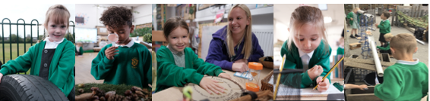
Academic Year 2025-2026
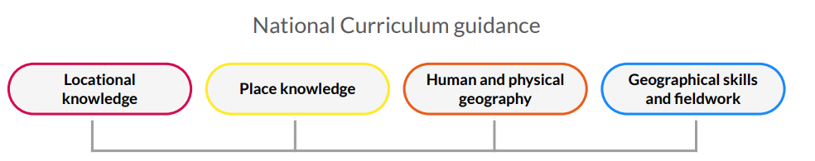
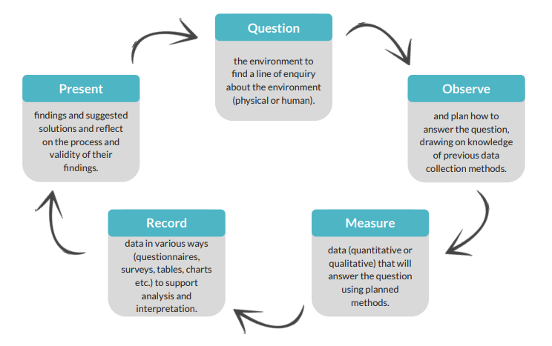
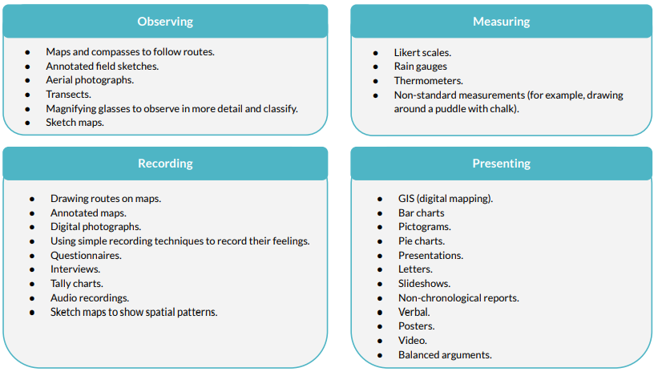
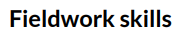
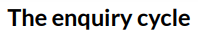

EYFS Geography Curriculum Overview 2024-2025

 | Autumn 1 |  | Autumn 2 | Spring 1 |  | Spring 2 | Summer 1 |  | Summer 2
EYFS | Exploring the seasons  Exploring the local area |  | Exploring the seasons  Exploring the weather  Using directional language/ spatial awareness. | Compare local area to contrasting environments |  | Seasonal Walk  Create journey sticks | Seasonal Walk  Directional language |  | Creating maps
How? | Seasonal Autumn Walk (school grounds)  Walk to the local care home. |  | Seasonal Winter Walk (school grounds).  Weather station.  Walk to the local post box and create a messy map of route. | Case study on a hot country and cold country (Antarctica and Africa) |  | Seasonal Spring Walk (school grounds)  Walk within school grounds. | Seasonal Summer Walk (school grounds)  Programming Bee-bots and walk to local church. |  | Making maps to find fossils.  Treasure maps.  Lytham Beach school trip.
EYFS Links | -Understand some important processes and changes in the natural world around them, including the seasons.  -Describe their immediate environment using knowledge from observation, discussion, stories, non-fiction texts and maps. |  | -Understand some important processes and changes in the natural world around them, including the seasons.  -Describe their immediate environment using knowledge from observation, discussion, stories, non-fiction texts and maps. | -Explain some similarities and differences between life in this country and life in other countries, drawing on knowledge from stories, non-fiction texts and (when appropriate) maps. |  | -Understand some important processes and changes in the natural world around them, including the seasons.  -Describe their immediate environment using knowledge from observation, discussion, stories, non-fiction texts and maps. | -Understand some important processes and changes in the natural world around them, including the seasons. |  | -Know some similarities and differences between the natural world around them and contrasting environments, drawing on their experiences and what has been read in class.
Suggested texts/ resources/enhancements | -The Snail and the Whale by Julia Donaldson (place and environment)  -We’re Going on a Bear Hunt by Michael Rosen and Helen Oxenbury (mapping, local area)  -Theme week- Locality Fortnight |  |  | -Story of a Storm by Mick Manning/ Brita Granstrom (weather/ storms). |  |  | -We're Going on a Bear Hunt by Michael Rosen/ Helen Oxenbury. (Journeys)  -Dinosaurs’ Day Out by Nick Sharratt (Mapping and vocab about places)  -Dinosaurs and all that rubbish by Michael Foreman (environment)
Year One Geography Curriculum Overview 2024-2025

 | Autumn 1 | Autumn 2 |  | Spring 1 | Spring 2 |  | Summer 1 | Summer 2
Year 1 (to be taught in this order) | What is it like here? |  |  | What is the weather like in the UK? |  |  |  | How is life different in Shanghai?
How? | -Use ariel photographs to locate where they live and recognise local features.  -Create simple maps of the school grounds.  -Follow simple routes using maps of the school.  -Carry out an enquiry on how to improve school playground. |  |  | -Study the countries and cities of the UK  -Discuss the seasons and weather.  -Think about how we change our behaviour in response to the different weathers.  -Investigate the UK’s hot and cold places using simple weather maps. |  |  |  | -Use a world map to begin to recognise continents, oceans and countries outside of the UK- focus on China.  -Identify physical features of Beijing from ariel photos and maps.  -Identify human features through exploring land-use in China.  -Compare human and physical features to the UK.  -Make a simple map through local fieldwork.
NC Links | -Use basic geographical vocabulary to refer to key physical features.  -Use basic geographical vocabulary to refer to key human features.  Vocab:  Ariel, globe, atlas, symbol, improve, map. |  |  | -Name, locate and identify characteristics of the four countries and capital cities of the United Kingdom and its surrounding seas.  -Identify seasonal and daily weather patterns in the United Kingdom and the location of hot and cold areas of the world in relation to the Equator and the North and South Poles.  Vocab:  Climate, rain gauge, weather vane, thermometer, atlas, continent, country. |  |  |  |  | -Name and locate the world’s seven continents and five oceans.  -Understand geographical similarities and differences through studying the human and physical geography of a small area of the United Kingdom, and of a small area in a contrasting non-European country.  Vocab:  Continent, country, human features, physical features, similar.
Suggested texts/ resources/enhancements | -Rosie’s Walk by Pat Hutchins (local area and mapping)  -Your Local Area Shops by Ruth Thomson (local area and vocab) |  |  | -Welcome by Barroux (Weather)
Year Two Geography Curriculum Overview 2024-2025

 | Autumn 1 |  | Autumn 2 | Spring 1 |  | Spring 2 | Summer 1 |  | Summer 2
Year 2 (to be taught in this order) | Would you prefer to live in a hot or cold place? |  |  | Why is our world wonderful? |  |  | What is it like to live by the coast?
How? | -Introduce the basic concept of climate zones and map out hot and cold places globally.  -Compare features in the North and South Pole, Kenya and local area.  -Learn the four compass points and names and locations of the seven continents. Use this language to describe features and routes on a map.  -Use simple fieldwork and observational skills to study the geography of their school and its grounds and the key human and physical features of its surrounding environment. |  |  | -Identify key features and characteristics of the UK before exploring another place in the world.  -Locate and name the oceans on a world map.  -Explore the natural habitats in their local area and use fieldwork to investigate and present this. |  |  | -Recap the surrounding seas of the UK and oceans.  -Identify physical features of the Jurassic Coast and how humans have interacted with this over time, land use, settlements and tourism.
NC Links | -Name and locate the world’s seven continents and five oceans using atlases, globes and world maps.  -Understand geographical similarities and differences through studying the human and physical geography of a small area of the UK, and of a small area in a contrasting non-European country.  -Identify seasonal and daily weather patterns in the UK and the location of hot and cold areas of the world in relation to the Equator and the North and South Poles.  Vocab:  Arid, climate, compass, continent, equator, vegetation. |  |  | -Name and locate the world’s seven continents and five oceans.  Name.  -Locate and identify characteristics of the four countries and capital cities of the United Kingdom and its surrounding seas.  -Use world maps, atlases and globes to identify the United Kingdom and its countries, as well as the countries, continents and oceans studied at this key stage.  -Use simple compass directions (North, South, East and West) and locational and directional language [for example, near and far; left and right], to describe the location of features and routes on a map.  -Use aerial photographs and plan perspectives to recognise landmarks and basic human and physical features; devise a simple map; and use and construct basic symbols in a key.  -Use simple fieldwork and observational skills to study the geography of their school and its grounds and the key human and physical features of its surrounding environment.  Vocab:  Airal photograph, OS map, scale, vegetation |  |  | -Name and locate the world’s seven continents, five oceans and the UK’s surrounding seas.  -Use world maps, atlases and globes to identify the United Kingdom and its countries, as well as the countries, continents and oceans studied at this key stage.  -Use simple fieldwork and observational skills to study the geography of their school and its grounds and the key human and physical features of its surrounding environment.  Vocab:  Aquarium, bay, coast, island, tourist.
Suggested texts/ resources/enhancements | -A Balloon for Grandad by Nigel Gray (human and physical geography) |  |  | -Katie Morag Island Stories by Maira Hadderwick (concept of place and mapping)  -Ben and Gran and the Whole, Wide, Wonderful World by Gillian Shields (explores different areas in the world). |  |  | -Winnie at the Seaside by Valerie Thomas and Korgi Paul  -Somebody Swallowed Stanley by Sarah Roberts (the environment/ recycling)  -At the Beach by Roland Harvey
Year Three Geography Curriculum Overview 2024-2025

 | Autumn 1 |  | Autumn 2 | Spring 1 |  | Spring 2 | Summer 1 |  | Summer 2
Year 3  (to be taught in any order) |  |  | Why do people live near volcanoes? | Are all settlements the same? |  |  |  |  | Who lives in Antarctica?
How? |  |  | -Look at the Earth’s structure, tectonic plates and boundaries.  -Look at how mountains are formed and types of volcanoes.  -Explore the cause of earthquakes and the positive and negative impacts of living in a volcanic environment.  -Map the global distribution of mountains, volcanoes and earthquakes. | -Explore different types of settlements, land use and the differences between rural and urban areas.  -Investigate human and physical features in the local area and the changes over time.  -Compare land use in India with the local area and identify key similarities and differences. |  |  |  |  | -Learn about longitude and latitude and their links to climate.  -Start to understand how the tilt of the Earth impacts the Antarctic circle and global temperatures.  -Explore physical features of a polar region and how humans have adapted to working there.  -Explore Shackleton’s expedition and plan their own using mapping and skills used so far.
NC Links |  |  | -Locate the world’s countries, using maps to focus on Europe (including the location of Russia) and North and South America, concentrating on their environmental regions, key physical and human characteristics, countries, and major cities.  -Understand geographical similarities and differences of a region of the UK, a region in a European country, and a region within North or South America.  -Describe and understand key aspects of: physical geography, including: climate zones, biomes and vegetation belts, rivers, mountains, volcanoes and earthquakes, and the water cycle.  -Describe and understand key aspects of: human geography, including: types of settlement and land use, economic activity including trade links, and the distribution of natural resources including energy, food, minerals and water.  use maps, atlases, globes and digital/computer mapping to locate countries and describe features studied.  Vocab:  Active volcano, composite volcano, dormant volcano, crust, igneous rock, magma, tectonic plate, seismic waves. | -Locate the world’s countries, using maps to focus on Europe (including the location of Russia) and North and South America, concentrating on their environmental regions, key physical and human characteristics, countries, and major cities.  -Name and locate counties and cities of the United Kingdom, geographical regions and their identifying human and physical characteristics, key topographical features (including hills, mountains, coasts and rivers), and land-use patterns; and understand how some of these aspects have changed over time.  -Understand geographical similarities and differences through the study of human and physical geography of a region of the United Kingdom, a region in a European country, and a region within North or South America.  -Describe and understand key aspects of: human geography, including: types of settlement and land use, economic activity including trade links, and the distribution of natural resources including energy, food, minerals and water.  -Use maps, atlases, globes and digital/computer mapping to locate countries and describe features studied.  -Use the eight points of a compass, four and six-figure grid references, symbols and key (including the use of Ordnance Survey maps) to build their knowledge of the United Kingdom and the wider world.  -Use fieldwork to observe, measure, record and present the human and physical features in the local area using a range of methods, including sketch maps, plans and graphs, and digital technologies.  Vocab:  Agricultural land, commercial land, dispersed, linear, settlement, transportation. |  |  |  |  | -Locate the world’s countries, using maps to focus on Europe (including the location of Russia) and North and South America, concentrating on their environmental regions, key physical and human characteristics, countries, and major cities.  -Identify the position and significance of latitude, longitude, Equator, Northern Hemisphere, Southern Hemisphere, the Tropics of Cancer and Capricorn, Arctic and Antarctic Circle, the Prime/Greenwich Meridian and time zones (including day and night).  -Describe and understand key aspects of: physical geography, including: climate zones, biomes and vegetation belts, rivers, mountains, volcanoes and earthquakes, and the water cycle.  -Describe and understand key aspects of: human geography, including: types of settlement and land use, economic activity including trade links, and the distribution of natural resources including energy, food, minerals and water.  -Use maps, atlases, globes and digital/computer mapping to locate countries and describe features studied.  -Use the eight points of a compass, four and six-figure grid references, symbols and key (including the use of Ordnance Survey maps) to build their knowledge of the United Kingdom and the wider world.  -Use fieldwork to observe, measure, record and present the human and physical features in the local area using a range of methods, including sketch maps, plans and graphs, and digital technologies.  Vocab:  Climate zone, drifting ice, hemisphere, ice sheet, ice shelf,  iceberg, lines of latitude, lines of longitude
Suggested texts/ resources/enhancements: |  |  | -Non-fiction - National Geographic Kids - Volcanoes  -DK Find out – Volcanoes  -Escape from Pompeii by Christina Balit | -Window (2002) Walker Books Jeannie Baker  -Belonging (2004) Walker Books – Jeannie Baker  -In the City by Roland Harvey (human and physical geography)
Year Four Geography Curriculum Overview 2024-2025

 | Autumn 1 |  | Autumn 2 | Spring 1 |  | Spring 2 | Summer 1 |  | Summer 2
Year 4  (to be taught in any order) | Where does our food come from? |  |  | Why are rainforests important to us? |  |  |  |  | What are rivers and how are they formed?
How? | -Look at the distribution of the world’s biomes.  -Map food imports from around the world. Learn about fair trade- specifically Côte d'Ivoire and cocoa beans.  -Where does their school dinner food come from?  -Explore the pros and cons of local versus global food. |  |  | -Look at the link between biomes and climate.  -Locate the Amazon rainforest and explain how the vegetation in a tropical rainforest is defined by the two Tropics.  -Investigate the physical features and layers of the Amazon rainforest, considering how plants adapt to these conditions.  -Learn about the people who live in the rainforest and discuss the impact of human activity locally and globally. |  |  |  |  | -Investigate and record different weather phenomena to develop an understanding of the water cycle.  -Map out the world’s major rivers and learn about the features and courses of a river.  -Study a local river as fieldwork and learn about ways in which humans interact with and use rivers locally and in a contrasting environment.
NC Links | -Locate the world’s countries, using maps to focus on Europe (including the location of Russia) and North and South America, concentrating on their environmental regions, key physical and human characteristics, countries, and major cities.  -Understand key aspects of a region, including climate zones, biomes.  -Describe and understand key aspects of: human geography, including: types of settlement and land use, economic activity including trade links, and the distribution of natural resources including energy, food, minerals and water.  -Use maps, atlases, globes and digital/computer mapping to locate countries and describe features studied.  Vocab:  Air freight, carbon footprint, consume, distribute, export, import, food miles. |  |  | -Locate the world’s countries, using maps to focus on Europe (including the location of Russia) and North and South America, concentrating on their environmental regions, key physical and human characteristics, countries, and major cities.  identify the position and significance of latitude, longitude, Equator, Northern Hemisphere, Southern Hemisphere, the Tropics of Cancer and Capricorn, Arctic and Antarctic Circle, the Prime/Greenwich Meridian and time zones (including day and night).  -Describe and understand key aspects of: physical geography, including: climate zones, biomes and vegetation belts, rivers, mountains, volcanoes and earthquakes, and the water cycle.  describe and understand key aspects of: human geography, including: types of settlement and land use, economic activity including trade links, and the distribution of natural resources including energy, food, minerals and water.  -Use maps, atlases, globes and digital/computer mapping to locate countries and describe features studied.  -Use fieldwork to observe, measure, record and present the human and physical features in the local area using a range of methods, including sketch maps, plans and graphs, and digital technologies.  Vocab:  Biome, buttress roots, canopy layer, deforestation, drought, emergent layer, indigenous people, lianas |  |  |  |  | -Locate the world’s countries, using maps to focus on Europe (including the location of Russia) and North and South America, concentrating on their environmental regions, key physical and human characteristics, countries, and major cities.  name and locate counties and cities of the United Kingdom, geographical regions and their identifying human and physical characteristics, key topographical features (including hills, mountains, coasts and rivers), and land-use patterns; and understand how some of these aspects have changed over time.  -Describe and understand key aspects of: physical geography, including: climate zones, biomes and vegetation belts, rivers, mountains, volcanoes and earthquakes, and the water cycle.  -Describe and understand key aspects of: human geography, including: types of settlement and land use, economic activity including trade links, and the distribution of natural resources including energy, food, minerals and water.  use maps, atlases, globes and digital/computer mapping to locate countries and describe features studied.  -Use the eight points of a compass, four and six-figure grid references, symbols and key (including the use of Ordnance Survey maps) to build their knowledge of the United Kingdom and the wider world.  -Use fieldwork to observe, measure, record and present the human and physical features in the local area using a range of methods, including sketch maps, plans and graphs, and digital technologies.  Vocab:  Condensation, delta, estuary, evaporation, irrigation, meander, precipitation, tributary.
Suggested texts/ resources/enhancements: |  |  |  | -The Explorer by Katherine Rundell and Hannah Horn (Place- the Amazon)  -Journey to the River Sea by Eva Ibbotson and Kate Hickey (Place- the Amazon) |  |  |  |  | -All the Water in the World By George Ella Lyon
Year Five Geography Curriculum Overview 2024-2025

 | Autumn 1 |  | Autumn 2 | Spring 1 |  | Spring 2 | Summer 1 |  | Summer 2
Year 5  (to be taught in any order) | What is life like in the Alps? |  |  | Why do oceans matter? |  |  | Would you like to live in the desert?
How? | -Explore the climate of mountain ranges and consider why people visit the Apls.  -Focus on Innsbruck and identify the human and physical features that attract tourism.  -Apply their learning to investigate local tourism, map recreational lands and present their findings. |  |  | -Explore the significance of our oceans, and learn how humans can impact them and how this has changed over time.  -Study the Great Barrier Reef and how plastic and pollution is damaging this marine environment, before considering positive environmental changes that can be made including making eco-friendly choices.  -Use fieldwork skills to investigate the amount and type of litter in their nearest marine environment. |  |  | -Explore biomes and their various characteristics.  -Study deserts and map deserts around the world, particularly focusing on those in North America. -Learn about the physical features of a desert and consider how humans interact with and have adapted to living in the desert.
NC Links | -Locate the world’s countries, using maps to focus on Europe (including the location of Russia) and North and South America, concentrating on their environmental regions, key physical and human characteristics, countries, and major cities.  -Name and locate counties and cities of the United Kingdom, geographical regions and their identifying human and physical characteristics, key topographical features (including hills, mountains, coasts and rivers), and land-use patterns; and understand how some of these aspects have changed over time.  -Identify the position and significance of latitude, longitude, Equator, Northern Hemisphere, Southern Hemisphere, the Tropics of Cancer and Capricorn, Arctic and Antarctic Circle, the Prime/Greenwich Meridian and time zones (including day and night).  -Understand geographical similarities and differences through the study of human and physical geography of a region of the United Kingdom, a region in a European country, and a region within North or South America.  -Describe and understand key aspects of: human geography, including: types of settlement and land use, economic activity including trade links, and the distribution of natural resources including energy, food, minerals and water.  -Use maps, atlases, globes and digital/computer mapping to locate countries and describe features studied.  -Use the eight points of a compass, four and six-figure grid references, symbols and key (including the use of Ordnance Survey maps) to build their knowledge of the United Kingdom and the wider world.  -Use fieldwork to observe, measure, record and present the human and physical features in the local area using a range of methods, including sketch maps, plans and graphs, and digital technologies.  Vocab:  Climate change, coniferous trees, deciduous trees, glacier, fold mountain, hemisphere, vegetation. |  |  | -Locate the world’s countries, using maps to focus on Europe (including the location of Russia) and North and South America, concentrating on their environmental regions, key physical and human characteristics, countries, and major cities.  -Name and locate counties and cities of the United Kingdom, geographical regions and their identifying human and physical characteristics, key topographical features (including hills, mountains, coasts and rivers), and land-use patterns; and understand how some of these aspects have changed over time.  describe and understand key aspects of: physical geography, including: climate zones, biomes and vegetation belts, rivers, mountains, volcanoes and earthquakes, and the water cycle.  describe and understand key aspects of: human geography, including: types of settlement and land use, economic activity including trade links, and the distribution of natural resources including energy, food, minerals and water.  -Use maps, atlases, globes and digital/computer mapping to locate countries and describe features studied.  -Use fieldwork to observe, measure, record and present the human and physical features in the local area using a range of methods, including sketch maps, plans and graphs, and digital technologies.  Vocab:  -biodegradable, buffer, coral bleaching, decompose, disposable, ecology, erosion, marine, microplastics |  |  | -Locate the world’s countries, using maps to focus on Europe (including the location of Russia) and North and South America, concentrating on their environmental regions, key physical and human characteristics, countries, and major cities.  -Identify the position and significance of latitude, longitude, Equator, Northern Hemisphere, Southern Hemisphere, the Tropics of Cancer and Capricorn, Arctic and Antarctic Circle, the Prime/Greenwich Meridian and time zones (including day and night).  -Understand geographical similarities and differences through the study of human and physical geography of a region of the United Kingdom, a region in a European country, and a region within North or South America.  describe and understand key aspects of: physical geography, including: climate zones, biomes and vegetation belts, rivers, mountains, volcanoes and earthquakes, and the water cycle.  describe and understand key aspects of: human geography, including: types of settlement and land use, economic activity including trade links, and the distribution of natural resources including energy, food, minerals and water.  -Use maps, atlases, globes and digital/computer mapping to locate countries and describe features studied.  -Use the eight points of a compass, four and six-figure grid references, symbols and key (including the use of Ordnance Survey maps) to build their knowledge of the United Kingdom and the wider world.  Vocab:  Airstrip, arid, barren, desertification, drought, mesa, ranching,
Suggested texts/ resources/enhancements: |  |  |  | -The Lorax by Dr Seuss (Global geography and sustainability and conservation)  -Under the Weather: Stories of Climate Change by Tony Bradman (climate change)
Year Six Geography Curriculum Overview 2024-2025
 | Autumn 1 |  | Autumn 2 | Spring 1 |  | Spring 2 | Summer 1 |  | Summer 2
Year 6  (to be taught in any order) | Why does population change? |  | Where does our energy come from? |  |  | Can I carry out an independent fieldwork enquiry?
How? | -Look at global population distribution and think about why certain areas are more populated than others.  -Explore the factors that influence birth and death rates and use case studies to illustrate these.  -Consider and discuss the social, economic and environmental push and pull factors that influence migration.  -Carry out fieldwork to explore the impact of population on the local environment. |  | -Learn about time zones around the world.  -Explore the natural resources and energy found in the United States and the United Kingdom.  -Learn about renewable and non-renewable energy sources and the impacts these have on society, economy and environment.  -Carry out a fieldwork investigation considering the best location for a solar panel on the school grounds. | - |  | -Observe, measure, record and present their own fieldwork study of the local area with a focus on the environment.  -Implement digital mapping, use of photographs, data collection and analysis, then culminate their ideas into a presentation explaining small changes that can be made to improve the quality of their local environment.
NC Links | -Locate the world’s countries, using maps to focus on Europe (including the location of Russia) and North and South America, concentrating on their environmental regions, key physical and human characteristics, countries, and major cities.  -Name and locate counties and cities of the United Kingdom, geographical regions and their identifying human and physical characteristics, key topographical features (including hills, mountains, coasts and rivers), and land-use patterns; and understand how some of these aspects have changed over time.  -Understand geographical similarities and differences through the study of human and physical geography of a region of the United Kingdom, a region in a European country, and a region within North or South America.  describe and understand key aspects of: human geography, including: types of settlement and land use, economic activity including trade links, and the distribution of natural resources including energy, food, minerals and water.  -Use maps, atlases, globes and digital/computer mapping to locate countries and describe features studied.  -Use fieldwork to observe, measure, record and present the human and physical features in the local area using a range of methods, including sketch maps, plans and graphs, and digital technologies.  Vocab:  Birth rate, cartogram, death rate, densely populated, migrants, refugee, migration, density. |  | -Locate the world’s countries, using maps to focus on Europe (including the location of Russia) and North and South America, concentrating on their environmental regions, key physical and human characteristics, countries, and major cities.  -Name and locate counties and cities of the United Kingdom, geographical regions and their identifying human and physical characteristics, key topographical features (including hills, mountains, coasts and rivers), and land-use patterns; and understand how some of these aspects have changed over time  -Identify the position and significance of latitude, longitude, Equator, Northern Hemisphere, Southern Hemisphere, the Tropics of Cancer and Capricorn, Arctic and Antarctic Circle, the Prime/Greenwich Meridian and time zones (including day and night).  -Understand geographical similarities and differences through the study of human and physical geography of a region of the United Kingdom, a region in a European country, and a region within North or South America.  -Describe and understand key aspects of: human geography, including: types of settlement and land use, economic activity including trade links, and the distribution of natural resources including energy, food, minerals and water.  use maps, atlases, globes and digital/computer mapping to locate countries and describe features studied.  -Use the eight points of a compass, four and six-figure grid references, symbols and key (including the use of Ordnance Survey maps) to build their knowledge of the United Kingdom and the wider world.  use fieldwork to observe, measure, record and present the human and physical features in the local area using a range of methods, including sketch maps, plans and graphs, and digital technologies  Vocab:  Biofuel, contour line, crude oil, emissions, hydropower, prime meridian, urban planner. | - |  | -Name and locate counties and cities of the United Kingdom, geographical regions and their identifying human and physical characteristics, key topographical features (including hills, mountains, coasts and rivers), and land-use patterns; and understand how some of these aspects have changed over time.  -Describe and understand key aspects of: human geography, including: types of settlement and land use, economic activity including trade links, and the distribution of natural resources including energy, food, minerals and water.  -Use maps, atlases, globes and digital/computer mapping to locate countries and describe features studied.  -Use the eight points of a compass, four and six-figure grid references, symbols and key (including the use of Ordnance Survey maps) to build their knowledge of the United Kingdom and the wider world.  use fieldwork to observe, measure, record and present the human and physical features in the local area using a range of methods, including sketch maps, plans and graphs, and digital technologies.  Vocab:  Analyse, data, enquiry, evidence, impact, justify, issue, subjective, viewpoint.
Suggested texts/ resources/enhancements: | -Refugee Boy by Benjamin Zaphaniah (enquiry and migration, global geography)  -We are Britain! by Benjamin Zaphaniah (cultural diversity and understanding)  -The Silence Seeker by Ben Morley and Carl Pearce (cultural diversity and migration)  -Gervelie's Journey: A Refugee Diary by Anthony Robinson, Anne-Marie Young (migration and diversity)
Fieldwork planner
Year group | Autumn | Spring | Summer
EYFS | Fieldwork locations/ opportunities:  Seasons walk- school grounds  Walk to local care home- Local area | Fieldwork locations/ opportunities:  Walk to the post box- Local area  Seasons walk- school grounds | Fieldwork locations/ opportunities:  Seasons walk- school grounds  Lytham Beach school trip
Year 1 | What is it like here?  Fieldwork locations/ opportunities:  Lesson 3 – Location: School grounds  Lesson 4 – Location: School grounds | What is the weather like in the UK?  Fieldwork locations/ opportunities:  Lesson 2 – Location: School grounds  Lesson 3 – Location: School grounds  Lesson 4 – Location: School grounds | What is it like to live in Shanghai?  Fieldwork locations/ opportunities:  Lesson 1: Location: Local area surrounding school.
Year 2 | Would you prefer to live in a hot or a cold place?  Fieldwork locations/ opportunities:  Lesson 5 – Location: School grounds | Why is our world wonderful?  Fieldwork locations/ opportunities:  Lesson 3 – Location: Local woodland or green space in the school grounds | What is it like to live by the coast?  Fieldwork locations/ opportunities:  Lesson 5: Location: A coastal town
Year 3 | Why do people live near volcanoes?  Fieldwork locations/ opportunities:  Lesson 6 – Location: School grounds | Who lives in Antarctica?  Fieldwork locations/ opportunities:  Lesson 6 – Location: School grounds | Are all settlements the same?  Fieldwork locations/ opportunities:  Lesson 3 – Location: Local area
Year 4 | Why are rainforests important to us?  Fieldwork locations/ opportunities:  Lesson 4 – Location: Local woodland or park | Where does our food come from?  Fieldwork locations/ opportunities:  Lesson 5 – Location: School grounds | What are rivers and how are they used?  Fieldwork locations/ opportunities:  Lesson 6 – Location: River environment
Year 5 | What is life like in the Alps?  Fieldwork locations/ opportunities:  Lesson 4 – Location: local area to focus on recreational land use (tourism) | Why do oceans matter?  Fieldwork locations/ opportunities:  Lesson 5 – Location: Marine environment (beach, river, reservoir, lake or pond) | Would you like to live in the desert?  Fieldwork locations/ opportunities:  None
Year 6 | Why does population change?  Fieldwork locations/ opportunities:  Lesson 5 – Location: Urban environment (e.g., town centre) | Why does our energy come from?  Fieldwork locations/ opportunities:  Lesson 6 – Location: School grounds | Can I carry out an independent fieldwork enquiry?  Fieldwork locations/ opportunities:  Lesson 4 – local area

