Lea Community Primary School


Academic Year 2024-2025
EYFS Curriculum Overview

Lea Community Primary School Curriculum Overview 2024-2025
EYFS
 | Autumn 1  7 weeks | Autumn 2  8 weeks | Spring 1  6 weeks | Spring 2  6 weeks | Summer 1  4 weeks 3 days | Summer 2  7 weeks
Overarching Topic | Who am I? | Who makes the rules? | Who is the mightiest of them all? | Can you fly me to moon? | How does your garden grow? | Where would we like to go?
Possible ideas/ lines of enquiry  (These may be adapted at various points to allow for children’s interests) | Birthdays  Superheroes  Autumn  Growing up  Family | Halloween  Bonfire Night  Diwali  Remembrance Day  Christmas  Winter | Chinese New Year  Weather  Landmarks  Recycling  Valentines Day | Spring  Easter  Looking after our world  Pancake Day  Easter | Planting  Minibeasts  Exploring food | Summer  Beach  Changes- moving on  Holiday
Enrichment | Art gallery for parents  Visit local care home | Visitors into class:  -Fire brigade  -Police  -Nurse  Walk to the post office | Farm/zoo visit | Space day  Walk to the library | Dobbies visitor/ trip  Chicks  Church visit | Lytham
Ambitions |  | Police  Teacher  Lollypop person | Vet  Zookeeper | Astronomer | Gardener | Bus driver  Pilot
Parental  Involvement | Class Dojo updates  Parents learning evening.  Phonics workshop  Art gallery for parents | Class Dojo updates Nativity  Maths workshop  Parents Evening  Secret reader (parents) | Class Dojo updates  Parent’s Picnic  Stay and play session. | Class Dojo updates  Stay and play session.  Secret reader (parents) | Class Dojo updates  Writing workshop  Share a story  Stay and Read morning | Class Dojo updates  Open evening- look how far we’ve come!
CL/ Literacy  (English) | Love Makes a Family  by Sophie Beer  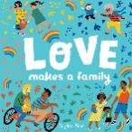  We’re Going on a Bear Hunt  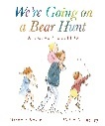  The Hedgehog Song by Lee Motram | The Queen’s Hat  by Steve Anthony  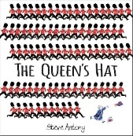  Queen Elizabeth (Little People, Big Dreams)  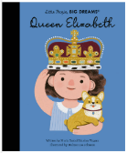  Grand Old Duke of York (rhyme) | Dear Zoo  by Rod Campbell  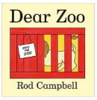  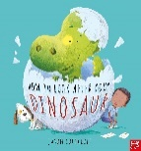  How to Look After Your Dinosaurs  by Jason Cockcroft  Down in the Jungle (Youtube) | Whatever Next!  by Jill Murphy  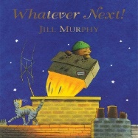  Look inside Space by Rob Lloyd Jones  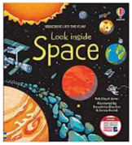  5 Little Men in a Flying Saucer | Jack and the Beanstalk  by Carly Gledhill  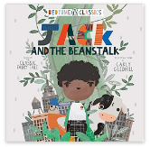  All About Plants  by Peter Riley  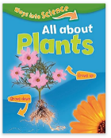  Incy Wincy Spider | The Naughty Bus  by Jan Oke  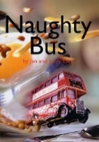  Emma Jayne’s Aeroplane by Katie Howath  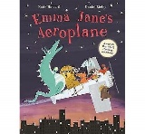  We’re all going on a summer holiday
Physical Development  (PE) | PE passport: (Baseline)  Fundamental movement skills | PE passport:  Castles | PE passport:  Rumble in the Jungle | PE passport:  Space | PE passport:  Jack and the Beanstalk  Sports Day Preparation | PE passport:  Transport  Dance unit:  Create a sequence of movements.
  PSED  (PSHE) | One decision  Sessions based on the needs of the children.  Key worker/circle time  Peer massage | One decision  Sessions based on the needs of the children.  Key worker/ circle time  Peer massage | One decision  Sessions based on the needs of the children.  Key worker/ circle time  Peer massage | One decision  Sessions based on the needs of the children.  Key worker/ circle time  Peer massage | One decision  Sessions based on the needs of the children.  Key worker/ circle time  Peer massage | One decision  Sessions based on the needs of the children.  Key worker/circle time  Peer massage
  Maths   | Subitising within 3  Counting skills  Composition of 3 and 4  Subitise objects and sounds  Comparing sets  Sorting objects  Taller and shorter  Shape patterns  Cross Curricular Link: Making apple crumble | Fiveness of 5  Comparing sets  Whole and part  Composition of 3,4,5  Counting skills  Matching numerals and quantities within 10  Counting beyond 20  2D Shapes  Day and night  Cross Curricular Link:  3D Christmas Tree | Subitise within 5  Match numerals to quantities within 5  Ordinality  More than  Focus on 5  Recognising 6 and 7 as 5 and a bit  Comparing sets  Making equal sets  Capacity  Height and length  Cross Curricular Link:  Making junk modelled animals. | Ordering numbers to 8  Less than  Doubles  Odd and even numbers  3D shapes  Patterns  Cross Curricular Link: Make a rocket and see which one goes the furthest. | Counting larger sets  Subitising to 6  Composition of 5 and a bit  Composition of 10  Comparision of numbers  Track games  Length and height  Full and empty  Shapes  Cross Curricular Link:  Measuring the beanstalks. | Subitise to 5  Rekenrek  Number bonds to 5  Composition of numbers to 10  Comparison  Number patterns  Counting  Length  Positional language  Cross Curricular Link:  Minibeast pictogram.
Understanding the World  (Science) | My Body  Simple body parts  Our senses  Healthy eating  Seasons  Autumn | Seasonal changes  Exploring day and night  Weather  Winter  Water freezing  (Look at a famous scientist- Little People, Big Dreams: Women in Science) | Animals  Identifying what animals need  Animals around the world | Materials  Naming materials  Waterproof materials  Exploring in nature  (Introduction to planets in our solar system through books/ songs)  Seasons  Spring | Plants  Name common plants  Planting runner beans  How to take care of living things  Life cycle of a chicken  Seasons  Summer | Being Healthy  Healthy food  Healthy lifestyle
Understanding the World  (History) | Who Am I?  Personal timelines  Comparing photos of themselves as babies/ now  Where do I live?  Local environment (past and present) | Who makes the rules?  Kings and Queens  Castles  Queen Elizabeth  People who help us (changes)  Remembrance Day | Who is Mary Anning?  Dinosaurs  Fossils  Significant figures from the past | Can you fly me to the moon?  Neil Armstrong  Moon landing | Was the Giant misunderstood?  Introduction to the concept of interpretations  Sequence events from the story | How do we travel?  Comparing photos of transport in the past and present  Ribble steam train  Should we welcome others?  Introduction to the concept of migration through stories
Understanding the World  (Geography) | Seasonal walk  (Autumn)  What can we see, hear, smell, feel? | Seasonal walk  (Winter)  Exploring the weather  Using directional language/ spatial awareness  Local area walk to the post office  (Messy map) | Compare local area to contrasting environments  (Look at animals in hot places/ cold places) | Seasonal Walk  (Spring)  Create journey sticks | Seasonal Walk  (Summer)  Directional language  (Programming Bee-bots) | Map making  Creating maps
  Computing/online safety | Computing through continuous provision | Computer systems and networks  Using a computer  Online Safety  (Penguin Pig) | Programming 1  All about instructions | Computer systems and networks  Exploring hardware  Online safety  (Smartie the Penguin) | Programming 2  Programming Bee-Bots | Data Handling  Introduction to data
Understanding the World  (RE) | Special times  Key Question/s: How and why do we celebrate? What times are special to different people and why? |  | Special stories  Key Question/s: Why are some stories special? What special messages can we learn from stories? |  | Our special world  Key Question/s: What is special about our world? | Special places  Key Question/s: What buildings and places are special to different people?
Expressive Arts  (Art) | Artist: Alma Thomas  Draw and display for parents  (Drawing)  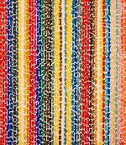 | Artist: Kandinsky  Calendars  (Painting)  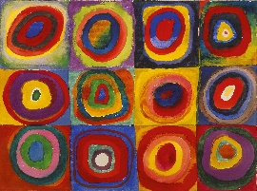 | Artist: Megan Coyle  Landscape collages  (Collaging)  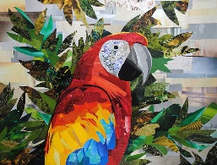 | Artist: Vincent Van Gogh  Starry night paintings  (Painting)  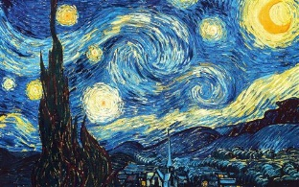 | Artist: Georgia O’Keefe  (Water colour Painting)  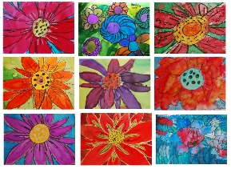 | Artist: Beth Cavener  Create a clay model  (Sculpture)  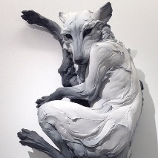
Expressive Arts  (Design and Technology) | Paper manipulation:  Scrunch, fold, bend, rip, cut, curl and combine paper  Cooking and nutrition:  Apple crumble | Mechanisms:  Create a Christmas card with a slider. | Junk modelling:  Use recycled materials to create animals. | Textiles:  Thread a bookmark (World Book Day)  Cooking and nutrition:  Create a healthy packed lunch | Junk modelling:  Use recycled materials to create a beankstalk | Cooking and nutrition:  Create a healthy picnic
Expressive Arts  (Music) | Ourselves and our friends  Musical elements  Pitch  Rhythm  Voices | Nativity songs  Musical elements  Pitch  Tempo  Dynamics | Dinosaurs  Musical elements  Pitch  Dynamics | Going places  Musical elements  Pitch  Tempo  Dynamics | Gardens and growing  Musical elements  Pitch  Tempo  Dynamics  Structure | People Who Help Us  Musical elements  Pitch  Dynamics  Structure

