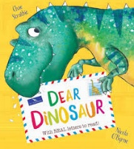
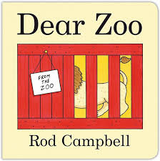
Curriculum Overview
Our learning this half term will be linked to the enquiry question ‘Who is the Mightiest of them all?’ This is our umbrella topic which means it is flexible and we always consider children’s interests to motivate them.
Communication and Language/ Literacy | Physical Development | Personal, Social and Emotional Development
This term we will continue to develop our reading and writing skills through our daily phonics lessons. In Literacy, we will be looking at the story ‘Dear Zoo’ and we will be retelling the story, in addition to innovating the well-known story. We will also be learning the poem ‘Down in the Jungle’ and exploring new vocabulary. As part of this, we will be writing our own ‘Down in the Jungle’ poem, including some of our new vocabulary.  We will continue to develop our vocabulary through discussions and listening to stories, whilst developing our prediction and inference skills. In preparation for Year One, we will be introducing the skill of proof-reading our work, to check it makes sense. | P.E. sessions will take place on a Tuesday. Children will be expected to arrive at school wearing their P.E kit. Please could you ensure long hair is tied back and jewellery is removed to avoid any accidents. This half term, we will continue to develop their fundamental movement skills such as hopping, jumping, running, throwing and catching. We will be doing this using the topic ‘Rumble in the Jungle’. We will also be completing a dance unit and working on children sequencing a series of movements into a sequence.  In class we will continue to work hard to develop our finger muscles through lots of fine motor activities. | This half term we will continue to develop our personal, social and emotional skills. We will also be encouraging children to see themselves as a unique and valued individual and talk about what makes them special.  We will continue to understand that children think and respond differently to each other and explore ways to show sensitivity to children’s different needs and feelings.  We will be encouraging children to seek out challenge and enjoy these challenges, by providing them with a safe environment to explore.  We will be continuing our peer massage sessions to help us to feel calm and emotionally prepared to learn.
Mathematics | Understanding the World | Expressive Art and Design
This half term, we will be consolidating all the knowledge we have been learning in EYFS. We will be practising our number bonds to 5 and 10, double facts, counting to 20 and beyond and subitising. We will also be using rekenreks to explore number composition to 10.  This term in shape, space and measure we will be looking at using positional language to describe where objects are. In addition, we will be exploring the relationship between Numicon value and shape and Cuisenaire rods. | This half term we will be learning about different animals around the world and what animals need to survive. We will also be learning about Mary Anning and thinking about her contribution to society and why she was significant. As part of this topic, we will be learning about different types of dinosaurs and exploring dinosaur fossils. We will be spending time reflecting on what makes us significant and our achievements in EYFS. We will continue to explore maps and we will be creating our own maps to find hidden fossils. In RE, we are exploring special places and thinking about why they are special to different people. We will also be thinking about what makes them special and what places are special to us. | In Art, we will be experimenting using different media, such as clay and playdough to create our own animal sculptures.  In DT we are looking at healthy eating and using this knowledge to make our own rainbow salad. The children will be encouraged to discuss the process of their work and evaluate their salad.  In music we will recap previously taught vocabulary and learning the new vocabulary of pitch, dynamics and structure. This will be through our music topic of dinosaurs.

Homework Overview
Reading |  | Maths |  | Phonics
Please ensure your child reads as frequently as possible and changes their book three times a week. Asking your child questions in relation to the book they are reading can help to develop their comprehension skills. Reading regularly with your child is essential to their early reading. |  | Please explore these websites to support your child with their understanding of numbers to 5 and subitising.  https://www.topmarks.co.uk/ordering-and-sequencing/shape-patterns  https://ictgames.com/mobilePage/index.html  https://www.topmarks.co.uk/early-years/lets-compare |  | We will upload lots of simple phonics games to Class Dojo to help your child build their phonological knowledge at home.  You can also access some of the free games from the following websites:  www.phonicsplay.co.uk  www.phonicsbloom.com
Understanding the World Challenge | Expressive Arts Challenge |  | Personal social and emotional development Challenge |  | Physical development Challenge
Can you create a poster about your favourite animal?    Research your chosen animal and find out what it needs to survive and how we can look after it. | Can you make a sculpture using clay?  Practice using the techniques we used in school to create your own model.  Don’t forget to send a picture on Dojo to show your friends!  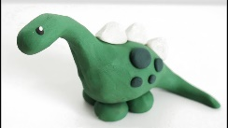  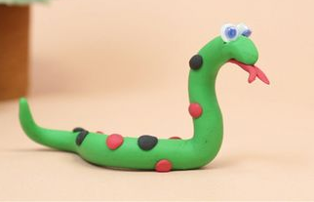 |  | In class we are continuing to work on sharing and turn taking.  Can you play a board game with your grown ups and take turns?  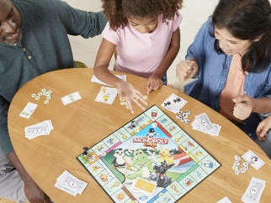 |  | 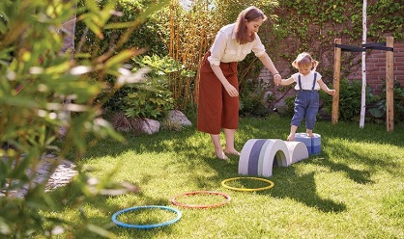  Can you create and obstacle course for you and your family to have a race with?
Week 1  Can you spot doubles in the environment? Explain to your adult why it is a double.  STEM sentence: ‘This is a double because ….. is a part and …… is a part.’  ‘4 is made of 2 and 2.  2 and 2 make 4.’ | Week 2  Practise ordering the numerals to 10 by asking your grown up to write the numbers on pieces of paper and mix them up.  Why not challenge yourself and see if you can order them to 20? |  | Week 3  Practise your number bonds to 5! Why not sing ‘5 Little Speckled Frogs’ and act out the song using objects. Whilst singing it, think about which two numbers make 5.  STEM sentence: ‘__ and ___ make ____. _____ is made of _____ and _____ |  | Week 4  Can you find 3D shapes around your house? Why not make a 3D model using the 3D shapes we have been learning about.
Week 5  Can you practise writing your numerals? Why not make your very own number line to 10!  For an extra challenge you could also draw the matching number of objects! | Week 6  Can you stomp your feet or clap to 30?  Make sure you don’t miss any numbers when counting!

