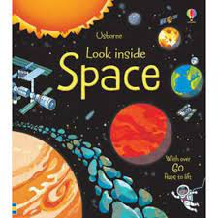
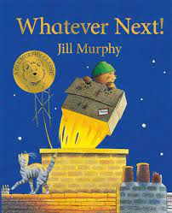
Curriculum Overview
Our learning this half term will be linked to the enquiry question ‘Can you fly me to the moon?’ This is our umbrella topic which means it is flexible and we always consider children’s interests to motivate them.
Communication and Language/ Literacy | Physical Development | Personal, Social and Emotional Development
This term we will continue to develop our reading and writing skills through our daily phonics lessons. In Literacy, we will be looking at the story ‘Whatever Next’ and orally retelling the story, in addition to writing a list of items we would need to take to space. We will also be creating a fact poster about a chosen planet and sending these to NASA to demonstrate our knowledge. We will continue to develop our vocabulary through discussions and listening to stories, whilst developing our questioning and reasoning skills whilst exploring space. We will also learn and perform the rhyme ‘5 little Men’ nursery rhyme. | P.E. sessions will take place on a Tuesday. Children will be expected to arrive at school wearing their P.E kit. Please could you ensure long hair is tied back and jewellery is removed to avoid any accidents. This half term, we will continue to develop their fundamental movement skills such as hopping, jumping, running, throwing and catching. We will be doing this using the topic ‘Space’. In class we will be working hard to develop our finger muscles through lots of fine motor activities. | This half term we will continue to develop our personal, social and emotional skills. We will continue to learn how to develop our resilience and perseverance when faced with challenges. We will also be looking at self-evaluating our work and the work of others.  We will be focusing on communicating our needs and making our own choices, to develop our independence.  We will be continuing our peer massage sessions to help us to feel calm and emotionally prepared to learn.
Mathematics | Understanding the World | Expressive Art and Design
This half term, we will continue to learn how to count to 20 and beyond. We will also start to learn odd and even numbers and link even numbers to doubles. We are continuing to develop our maths skills by exploring the composition of 10 and start to compare numbers, knowing which is more and which is less.  This term in shape, space and measure we will begin to explore which 3D shapes roll or can be stacked. We will also explore more complex repeating patterns. | This half term we will be learning about space and the first moon landing. We will be comparing the first moon landing to our space station now.  We are also exploring materials and starting to look at their properties. We will be investigating if a material is waterproof or if it sinks or floats. We will also continue to look at contrasting environments around the world and start to identify human and physical features. We will look at the changes in the weather and discuss what happens in Spring. In RE, we are continuing to look at stories and why they are special, focusing on Eid, Ramadan and Easter. | In Art, we are further developing our threading skills to create Easter crafts and we will be planning our crafts. In DT, we are carefully planning our own boats and investigating which material and shape makes the most effective boat. We will  continue to develop our imaginative skills by using a range of junk modelling equipment to create a desired outcome. In Music, we will be describing the tempo of a piece of music and understand why artists have created this effect.
Homework Overview
Reading |  | Maths |  | Phonics
Please ensure your child reads as frequently as possible and changes their book at least once a week. Asking your child questions in relation to the book they are reading can help to develop their comprehension skills. Reading regularly with your child is essential to their early reading. |  | Please explore these websites to support your child with their understanding of numbers to 5 and subitising.  https://www.topmarks.co.uk/Search.aspx?Subject=16&AgeGroup=1  https://ictgames.com/mobilePage/index.html  https://www.topmarks.co.uk/early-years/lets-compare |  | We will upload lots of simple phonics games to Class Dojo to help your child build their phonological knowledge at home.  You can also access some of the free games from the following websites:  www.phonicsplay.co.uk  www.phonicsbloom.com
Understanding the World Challenge | Expressive Arts Challenge |  | Personal social and emotional development Challenge |  | Physical development Challenge
Find out about one of the planets and create a poster with some key facts and drawings. 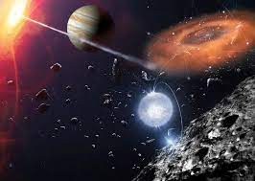 | Can you experiment using different recycled materials and make your own boat?  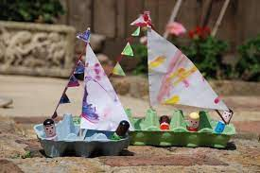  What materials are the best? Are they waterproof? Do they sink or do they float? |  | In class we have been talking about our mental health and how to live a healthy lifestyle.    Can you join in with one of the yoga videos and relax?  https://www.youtube.com/@CosmicKidsYoga |  | 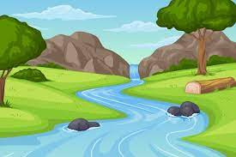  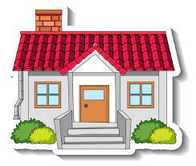  Go for a walk with your grown-ups and see if you can spot and human or physical features. Don’t forget to send us some pictures on Class Dojo!
Week 1  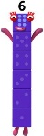  Talk about the number six. What is one more/ one less? Can you find a number six in the environment? Can you collect things that represent the number six? What two numbers make 6? | Week 2  Talk about the number seven. What is one more/ one less? Can you find a number seven in the environment? Can you collect things that represent the number seven? What two numbers make 7?   |  | Week 3  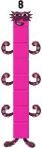  Talk about the number eight. What is one more/ one less? Can you find a number eight in the environment? Can you collect things that represent the number eight? What two numbers make 8? |  | Week 4  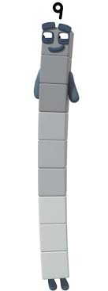  Talk about the number nine. What is one more/ one less? Can you find a number nine in the environment? Can you collect things that represent the number nine? What two numbers make 9?
Week 5
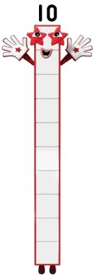
Talk about the number ten. What is one more/ one less? Can you find a number ten in the environment? Can you collect things that represent the number ten? What two numbers make 10?

